EDINBURGH
PRESBYTERY PLAN
CONSULTATION DOCUMENT 2022-2025
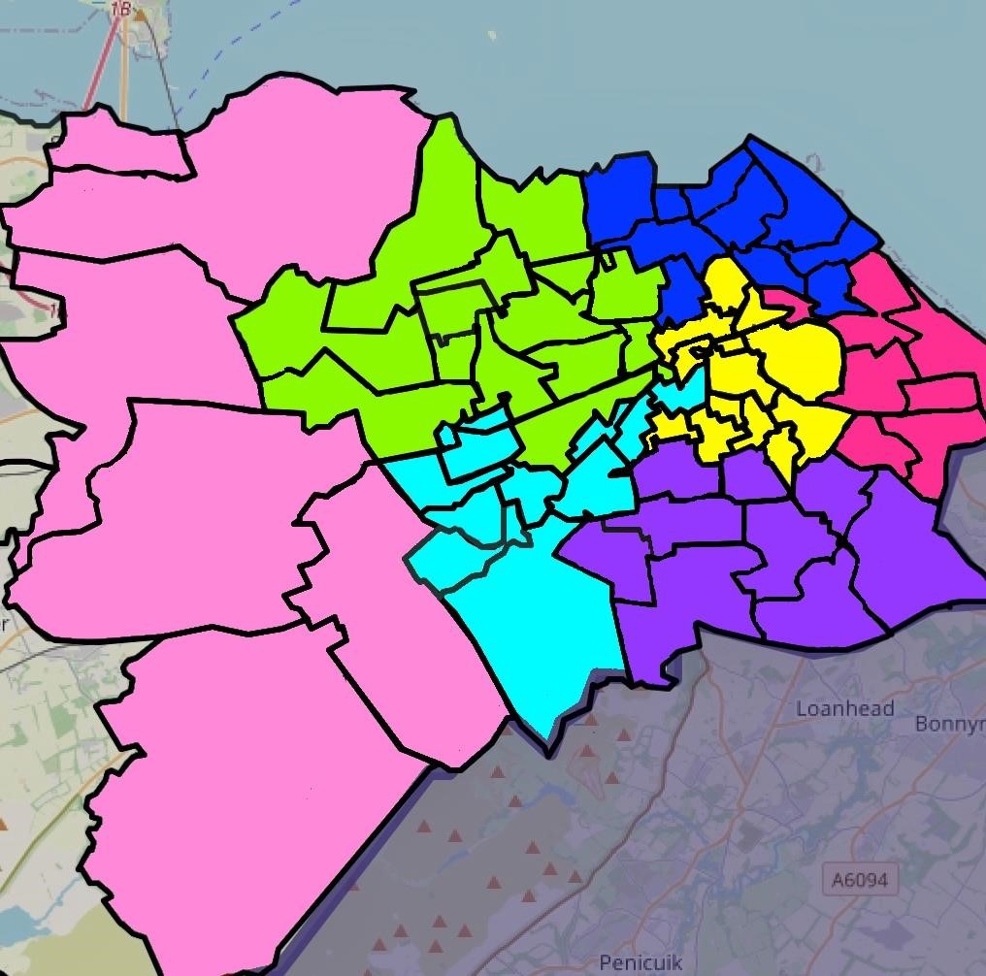

Contents
2 Contents
6 Acronyms

The Narrative
- Introduction
General Assembly May 2021
- The Road Map to the Plan
The 5 Marks of Mission
The Secondary Principles in the Act are also important
- Parishes and Mission Districts
Parishes and Ecumenical Working
Priority for the Poor
- The Whole People of God
The Mission Plan
Decision Making
- Diversity of Posts
Presbytery Funded Posts
New Parish Structures
- Moderators of New Unions
New Missional Opportunities
Finance
Deficits
- Buildings and Congregations
A Post Covid World

- West Lothian
Reviewable Charges and Tenure
Consequence of Planning
- Conclusion

The Clusters
- Mission District A – SOUTH WEST
- Mission Narrative for Mission District A 18 Mission District B – CENTRAL
19 Mission Narrative for Mission District B 20 Mission District C – NORTH
- Mission Narrative for Mission District C
- Mission District D - WEST
- Mission Narrative for Mission District D
- Mission District E - EAST
- Mission Narrative for Mission District E 27 Mission District F - SOUTH
- Mission Narrative for Mission District F
- Mission District G – BORDER
- Mission Narrative for Mission District G
The Changes

Mission District A – South West
31 1 Colinton - Juniper Green - Slateford Longstone
- 2 Holy Trinity (PA) - St Nicholas Sighthill
- 3 Carrick Knowe and St David’s Broomhouse
- 4 Barclay Viewforth and Craiglockhart, Polwarth and St Michael’s
- Cluster B - Central
37 1 Canongate and High St Giles’
- 2 Greyfriars and St Cuthbert’s
- 3 Broughton St Mary’s, Greenside and St Andrew’s and St George’s West
- 4 Craigmillar Park, Mayfield Salisbury and Priestfield
- 5 Marchmont St Giles’ and Morningside United and St Catherine’s Argyle

Cluster C - North
- 1 Granton and Wardie
- 2 Leith North, Leith South and Newhaven
- 3 Leith St Andrew’s, Pilrig St Paul’s and St Margaret’s
49 4 Inverleith St Serf’s and Stockbridge

Cluster D – West
- 1 Corstorphine St Anne’s and Murrayfield
- 2 Gorgie Dalry Stenhouse and Palmerston Place
- 3 Corstorphine St Ninian’s and St Andrew’s Clermiston
- 4 Cramond, Drylaw and Old Kirk Muirhouse
- 5 Blackhall St Columba’s, Davidson’s Mains and St Stephen’s Comely Bank
- 6 Corstorphine Craigsbank and Corstorphine Old

Cluster E
- 1 Meadowbank, Portobello and Joppa and Willowbrae
- 2 Bristo, Duddingston, Richmond Craigmillar (PA) and St Martin’s

Cluster F – South
59 1 Gracemount, Liberton, Liberton Northfield and
Tron Kirk Gilmerton Moredun
- 2 Morningside and Reid Memorial
- 3 Fairmilehead, Greenbank and St John’s Colinton Mains

Cluster G – Border
- 1 Dalmeny and Queensferry
- 2 Kirkliston and Ratho
- 3 Balerno and Currie

The Appendices
66 Appendix 1 - GENERAL ASSEMBLY - PRESBYTERY MISSION PLAN ACT – ACT 8,

MAY 2021
86 Appendix 2 - LOCAL MISSION CHURCH REGULATIONS (REGS II 2021)
- Appendix 3- STRATEGY COMMITTEE REMIT – SEPTEMBER 2018
- Appendix 4 - PRESBYTERY STRATEGIC PLAN – VALUES AND PRINCIPLES –

SEPTEMBER 2019
93 Appendix 5 – PRESBYTERY MAPPING EXERCISE
95 Appendix 6 – MISSION DISTRICTS STATISTICS

Acronyms

FTMWS |  | Full Time Minister of Word and Sacrament
MDS |  | Ministry Development Staff
OLM |  | Ordained Local Minister
PA |  | Priority Area
RT |  | Restricted Tenure
T |  | Transition Minister
UT |  | Unrestricted Tenure
WPCS Work Place Chaplaincy Scotland
V Vacancy

Introduction

“Follow Me”
Our challenge as a church is to deliver the Good News of Jesus Christ to the City of Edinburgh, both now and during the period of the city’s substantial projected growth.

We are a capital city with a Parliament, we are a world leading centre for the financial sector and we are a globally significant player in the Arts. We are also a diverse range of communities with significant gaps between the poorest and the richest.

The Presbytery Mission Plan must be founded in the challenge to the church to find its voice and plan for its growth and sustainability as we move to the future. During biblical times, the church had an unshakeable belief that God was with them in their challenges. In the shadow of the Covid pandemic we must reaffirm our belief that God is with us: we need to have the vision to embody the Missio Dei, or in plain English, to find out what God is doing and join in this adventure. This requires us to be nimble and creative and to be prepared to grasp opportunities to share the Good News in the parishes we are called to serve.

Edinburgh has been largely shielded from many changes in the Church of Scotland. The Presbytery has significant resources, both financial and in its personnel. However, in the last few years, many Presbyteries have found it difficult to recruit Ministers and parishes have experienced long vacancies. There has been a significant reduction in the number of men and women in the Ministry of Word and Sacrament; those entering ministry now tend to be older and many are nearing retirement. Edinburgh must play its part in addressing these national challenges. We are therefore required to make a significant cut in the number of ministries posts we are permitted to have, and this will be shocking to many in the Presbytery.

This Plan has had to wait for the publication of the Church of Scotland’s Act 8, 2021 (Presbytery Mission Plan Act: see appendix 1 and the accompanying Local Mission Church Regulations (Regs II 2021) at appendix 2) to enable it to be finalised. The remit of the Strategy Team (appendix 3) and the Values and Principles on which this Mission Plan is built (appendix 4) have also been reproduced so that members of Presbytery and congregations have all of the background information they will need as they consider the proposals for the future shape of ministry and mission across the city.

General Assembly May 2021
The Presbytery Mission Plan must be agreed by December 2022 at the latest. It will apply until December 2025, with a review each year. The General Assembly of 2021 agreed a limit on the number of posts (Ministers, Deacons and Ministries Development Staff) for each Presbytery. The Presbytery of Edinburgh has been given a limit of 48.5 posts. This is a reduction of 29.5 posts from the current limit: that represents a 40% reduction.

Road map to the Plan
All these challenges lead to the need for a radical rethinking of how Edinburgh delivers ministry and the ordinances of religion to the city.
The Strategy Team has scrutinised travel routes and public transport in the city, noting that, unlike in rural Presbyteries, most people in Edinburgh can easily access a congregation using public transport. Account has been taken of current parish populations and areas. In addition, the Strategy Team has reviewed how health, local government and national government are delivered in the city to help judge whether our plans are reasonable. (Some of the information on which this Plan relies is reproduced in appendix 5.)
Eighteen Cluster Groups were originally identified, and congregations began conversations. The clusters have reported, sometimes more than once, as they considered their mission priorities and developed ideas about their future. Some innovative ways of working were identified, and it is hoped that these suggestions will be implemented by congregations as they move forward. However, a more radical solution is required to get us to the number of posts we are permitted to deploy.
Mission is at the heart of all that we do, and we must think and act in a radical fashion. The Presbytery Planning Strategy Team began their work within the framework of the clusters but realised that for an effective radical mission plan to emerge, there was a need for a level of change and innovation that had not previously been envisioned. Act 8, 2021 places the 5 Marks of Mission at its heart and also sets out a number of vital Secondary Principles; the proposed Mission Plan has been structured around both.

The 5 Marks of Mission
- To proclaim the Good News of the Kingdom
- To teach, baptise and nurture new believers
- To respond to human need by loving service
- To seek to transform unjust structures of society, to challenge violence of every kind and pursue peace and reconciliation
- To strive to safeguard the integrity of creation and sustain and renew the life of the earth developed

The Secondary Principles
- Each community shall be served by a parish
- We will work Ecumenically
- We will have a priority for the Poor
- The Whole People of God will be encouraged and called out to exercise their gifts
- There will be worshipping, witnessing and serving Congregations within easy access of everyone in Edinburgh
- A mixed economy of existing Church structures and New Expressions of Faith will be encouraged
- Each Congregation must be financially viable and realistic
- Buildings must be “well equipped spaces in the right places”

Parishes and Mission Districts
Every congregation in the Presbytery of Edinburgh engages in mission as viewed through the lens of the Five Marks of Mission. There is evident variety in the manner in which mission is manifested according to local circumstance. Every congregation also participated in the cluster conversations. Some conversations sparked ideas, enthusiasm and closer connections and others clearly indicated that stronger partnerships may lie elsewhere. Priority for the Poor and lay training were two of the Secondary Principles of Mission emphasised in these conversations.

Congregations can no longer act in isolation but will instead work together, sharing resources and encouraging and supporting each other, particularly where a disparity of wealth, resources and gifts exists. Each parish will be part of a Mission District: a local network of churches inspiring, influencing, and leading mission and ministry. The original 18 Clusters will be reduced to seven Mission Districts, serving larger areas. It is incumbent upon each congregation to make this vision a practical reality, with the support of Presbytery and the wider church.

The Mission Districts proposed below are based on previous discussions and yet adjusted according to a wider framework, perspective and network of connections and relationships. That is, it is envisaged that working with other current congregations in Unions and working across a Mission District will strengthen their Mission through shared gifts and resources. This approach thus fulfils the commitment of the Church of Scotland to its territorial ministry in Scotland.

Parishes and Ecumenical Working
Act 8, 2021 places on us an obligation to work ecumenically. Edinburgh is a relatively small area and is very well served by many Christian denominations. The Mission Plan therefore includes an expectation that each Mission District will work ecumenically and collegially with other denominations in the area for the good of the Kingdom. This aspect of the future work of the Presbytery will be embedded in the Annual Review of the Plan.

Priority for the Poor
The Church of Scotland continues to have a priority for the poor, as is stated in the Secondary Principles above. The word Poor has been used without prejudice.

There are now only two Priority Areas (PA) parishes in Edinburgh, each of which is allocated double weighting of posts in accordance with National planning principles. The Presbytery Plan reflects this commitment and promotes the principle of stronger congregations and more vulnerable congregations working in partnership, with support being provided in various forms in both directions. This acknowledges that support can, and should, go both ways, recognising individual churches’ strengths.

The Whole People of God
The Presbytery is preparing courses to encourage its members to engage in fruitful mission. Training courses in worship, pastoral care, pioneer ministry and new expressions of faith are being progressed locally and nationally. It is proposed that a new post of Mission Facilitator will be established which will have an important role in developing missional thinking, providing support and delivering training at a local level to resource every Mission District.

The Mission Plan
The Mission Plan is aspirational in the search for growth. The Gospel story of the pruning of the vine illustrated to the early believers that for growth, there had to be pruning, with what was left having renewed potential for growth. This message is still true for us today. Presbytery must reduce its total of nationally funded Ministries posts to 48.5 but this pruning can result in renewed and stronger growth. The Mission Plan requires every congregation to think and act radically for the building of the Kingdom. The Mission Plan provides for consolidation of what is already going well at the parish level and opens up the prospect of growth, supported by a new configuration of congregations and ministries.

Decision-making
All proposals are based on evidence from congregations themselves and on information from a wide range of sources. Some congregations have been forthcoming and ‘brave’ in their assessment of their strengths and weaknesses. Many have informed Presbytery of the challenges they face, whether these be financial, fabric or missional; their honesty is valued.
Decisions have not been easy or straightforward; often, the proposals are multi-layered and have been affected by consideration of the whole area and the position of other congregations. Proposals have been based firmly on the number and nature of the nationally funded posts we need to deploy for mission and not on which posts we need to lose to get to the number required by the General Assembly.
We have been evidence led and have been aided in this by looking at
- Reports of Cluster discussions
- Submissions from individual churches
- Property Toolkit responses
- Various years of financial reporting and trends
- NHS districts
- Transport links
- Scottish Parliamentary Boundaries
- Local Council Boundaries
- Data on areas of multiple deprivation
- Areas of significant projected change, including population
- Capital City opportunities in arts and entertainment, finance, armed forces, Government and tourism.

Diversity of posts
48.5 posts will be nationally funded posts; this number includes Ministers of Word and Sacrament, Deacons and Mission Development Staff. Edinburgh is most fortunate that, in addition, some congregations can and do fund local posts. Also, the Finance Committee is proposing to release money from existing Mission Funds to fund up to two additional posts for the period of the Plan, to establish Presbytery-wide developmental roles. We will also continue to rely heavily on the valuable service provided by non-stipendiary posts such as OLMs, Readers, and by newly trained lay ministry; indeed, Presbytery hopes to develop such roles further.

Presbytery Funded Posts
We have identified a missional need for some short-term development posts in addition to the nationally funded posts. They will serve the whole Presbytery but may be sited within a building or congregation, with appropriate oversight but with outreach to a specific sector. Where possible, such work will be carried out in partnership with Work Place Chaplaincy Scotland, ecumenical and interfaith bodies and other appropriate organisations. The posts we propose are:

• Outreach Minister to the Under 40s
Begin a new initiative specifically designed to bring students and young people together where they are

• Chaplain to the Arts
The proposal is to bring the world of the Arts to marginalised and excluded communities. The role will also communicate to congregations what we can learn from the Arts to add to our worship and mission.

• Social Media/Communications Facilitator
The post will be held by someone who has experience in social media/online worship/communication to aid congregations in establishing and developing their online presence and good practice in the post Covid world.

• Scoping Exercise for Community Spaces
A short-term exercise to audit the community spaces in Edinburgh Presbytery to establish how best to use them for missional purposes. The Mission Coordinator will then help to establish appropriate new projects in areas of identified need.

New Parish Structures
The Plan must reflect what is best for the Presbytery of Edinburgh. Act 8, 2021 offers a range of possibilities for structuring church, all of which were explored in depth. Building on the largely positive experience of congregations meeting, listening, and sharing in Clusters, the proposal presents congregational unions, supported by newly created Ministry Teams, as the vehicle for radical change. Unions will permit the sharing of resources and skills and will provide new opportunities for the people of God to undertake mission and ministry together.

Moderators of New Unions
Under Act 8, 2021 where there is a team ministry, it must be decided which Minister will be the Moderator of the Kirk Session. This should be the person with the best gifts and aptitudes for the task. It should not be assumed that the Minister designated as the Moderator of the Kirk Session is the most senior person in terms of service, nor that the other minister(s) has/have a lesser role. Each member of the team will be encouraged to serve to their strengths.

New Missional Opportunities
There are large housing developments being built on the edge of Edinburgh. This is an opportunity for the Presbytery of Edinburgh to share the Good News of Jesus Christ in new ways. A few congregations are being asked to plant new ecclesial communities in these areas and others may wish to offer support. The creativity and energy of those who feel called to engage in this new ministry should be encouraged and supported by the Mission Districts. By stepping out in faith we show our commitment to growth and not just to the status quo.

Finance
Edinburgh is a wealthy Presbytery and contributes a substantial amount to the finances of the national Church. We provide significant sums which pay for many Ministries of Word and Sacrament, Deacons and Ministries Development Staff, as well as national and international working.

Our challenge is to ensure that pruning does not mean that we can no longer afford to pay for the posts that we, and the wider Church, need. We know from experience that closing too many buildings has proven in the past to lead to a reduction in membership and income. The Presbytery Strategy Team, working with the Finance Committee, has had to take a broad view on this matter and it has been extremely challenging.

Deficits
There is an expectation that congregations must exercise financial responsibility. The secondary principles are clear that each Congregation must be financially viable and realistic. There are concerns that various congregations run at a consistent operational deficit. There is a difference between those congregations which have an active attitude to maintaining a balanced budget, and those where complacency is a cause for concern, as well as those with large reserves. The Finance Committee stands ready, as always, to advise and support congregations in managing their finances responsibly.

Buildings and Congregations
The national accepted wisdom is that there are too many buildings. However, this Mission Plan proposes that where there is a clear mission imperative, then most buildings will be retained in some manner. However, the buildings which will best serve the Church and the community will be “well equipped spaces in the right places”. This means that some buildings will require to be released.

Some church buildings are not fit for purpose without a large investment outlay just to make them viable. Others are in the wrong place, and some do not comply with current building regulations. Some buildings will therefore be sold. Congregations should note that mission is the driving force behind this Plan. It does not follow, therefore, that a wealthy congregation will be permitted to keep its building. It might well be more appropriate instead for such a building to be released and for the congregation to unite with a poorer congregation in a building which is a “well equipped space in the right place”, in order to maximise the missional benefits.
There may also be a need to transport a congregation from one building to another for mission purposes, particularly if the building is no longer in the right place or is not fit for purpose. There may also be a need to plant a new congregation in a new place and for a building to be released to permit a new development. Areas of new housing may well be better served with a new church built in that location. We aspire to plan for growth.
The same issues of suitability and standards apply to manses. Fewer manses will be required. Do our manses meet current regulations, and how expensive are they to maintain? We need to be sensible and prudent in assessing these matters.
In making the proposals in the draft Mission Plan, the Strategy Team has taken account of the responses of congregations to the General Trustees’ Property Toolkit; it has also taken an in depth look at several years of each congregation’s accounts and has consulted with the Presbytery Property and Finance Committees as well as the national Presbytery Planning Advisory Group, the Principal Clerk, the Solicitor to the Church and the General Trustees.

A Post Covid World
The challenge of Covid and the new ways of worshipping, witnessing, and identifying with faith and its practice in the last year mean that no congregation and parish has yet returned to what used to be their normal faith practice, nor will they have had time to develop something completely new. Mission Districts will consider how their member congregations can fulfil Christ’s vision that all people ‘might have life and have it in abundance’. This may call for new ways of engaging online with the city as it learns to live with the effects of a global pandemic. Consideration will also have to be given to the balance of worship, in person and online. This is a challenge which will not go away. Online worship, bible study and church meetings have the potential to reach people all over the world who might be searching for a faith framework.

West Lothian
The parishes in Edinburgh which Border West Lothian run in a clear line north to south. There are significant challenges in relation to new housing developments to both the west of Edinburgh and the East of West Lothian. Each have similar challenges and the intention is to work together in this area to provide a missional approach to these areas. Conversations will begin on 1st January and thereafter with the intention of the new Presbytery working together to deliver the Good News of Jesus Christ jointly and to consider the best ways and new ways of being Church in these areas. We are confident that the Edinburgh Border Mission District will fit into the geographical split of West Lothian Presbytery and in the New Year might also mean an amalgamation of Mission Districts if appropriate.

Reviewable Charges and Tenure
A Reviewable Charge is the tool by which a Presbytery has the flexibility to adjust its parishes. The proposals in the draft Mission Plan are based on what the Strategy Team thinks is best for the Presbytery to achieve the radical missional change that is required. Implementation of the Plan will mean that some Reviewable Charges within Edinburgh will, of necessity, be reviewed. However, there are also proposals which will affect Ministers on Full Tenure.

There is a national discussion currently underway about the place of tenure and it is possible that a deliverance on this matter will come to the General Assembly of 2022. Presbytery will need to consider how best to implement the Mission Plan, when agreed, taking account of the limitations and opportunities surrounding matters of tenure. In the meantime, vacancies will be treated on a case-by-case basis by both the Presbytery and the Faith Nurture Forum. The General Assembly of 2021 encouraged ministers on full tenure to embrace change and to consider for themselves whether God could be calling them to new ministries and mission opportunities; we endorse this and urge Edinburgh ministers to engage actively and positively with the draft Mission Plan.

Consequence of Planning
Where any Conditions in relation to Ministry Development Staff (MDS) posts are altered, Human Resources of 121 must be formally consulted and the appropriate employment consultation process will be followed. This is a confidential process and therefore not for further discussion in the Presbytery planning process. Line managers of MDS posts are encouraged to be particularly sensitive to this process and, where necessary, provide the necessary communication and pastoral support. At this stage of the Presbytery Mission Planning process, it is not yet known what posts will be affected in the final Plan.

Conclusion
The proposals which follow see the creation of seven Mission Districts which will enable congregations to deliver mission and ministry to a city which is radically changing. For new things to begin, some things need to stop. For new parishes to be planted, some over-churched areas must be thinned out so that Presbytery can plan for growth in new areas. Energy and resources will be released to permit congregations to focus on perhaps a smaller number of local mission initiatives; some ministers will be released to engage in a more strongly mission orientated ministry. This will allow us to transform our communication of the Gospel in a post Christian society. The challenge is great, but we believe that God is at work in these times and that we will be supported and guided as we step forward in faith.

Cluster A – SOUTH WEST
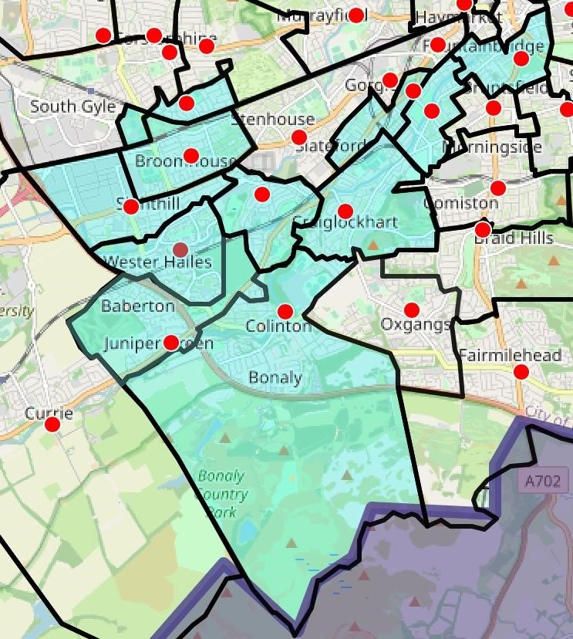

PARISHES
- Colinton, Juniper Green, Slateford Longstone
- Holy Trinity Wester Hailes, St Nicholas’ Sighthill
- Carrick Knowe, St David’s Broomhouse,
- Barclay Viewforth, Craiglockhart, Polwarth, St Michael’s
Population of parishes 80,116
Average population of Parish 20,029
Number of Posts Ministers 7
MDS 0

Mission Narrative for Mission District A – South West

Many of the congregations here have already cultivated connections with each other. There is a variety of congregational strengths, gifts, and approaches to mission. Some of these congregations exist within areas of significant need and others, while located in less challenging socio-economic circumstances, have manifested an awareness and engagement in supporting people locally, nationally, and internationally. There is an enthusiasm and energy in several of the congregations that can motivate all the congregations in the district. There is a variety of styles of leadership, there are different financial circumstances and a combination of potentially creative use of buildings alongside worrying fabric issues. Working across the boundaries of current congregations and future unions will allow mission in this geographical area to flourish.

Thus, the following is proposed:

- Mission District A will contain four congregations by the end of the plan with a total of seven Full Time Ministers of Word and Sacrament (FTMWS) and one 0.5 Ministry Development Staff (MDS). It will be complemented by two Ordained Local Ministers (OLM) and locally appointed staff as necessary.

- Colinton, Juniper Green and Slateford Longstone will be served by two FTMWS. The history, stability and outward orientation of Colinton will complement recent developments at Juniper Green (and especially possible outreach to the Baberton area) and the opportunities afforded by initiatives and needs in the Slateford Longstone parish.

- Holy Trinity (a Priority Area with double weighting for posts) and St. Nicholas Church Sighthill will be served by two FTMWS, complemented by two OLMs and local staff. Both churches have shown an energy, enthusiasm, and effectiveness in reaching out to a local area of need. Both churches have also expressed a concern about building capacity for their mission. To harness the possibilities, discussions regarding future building provision should begin with some urgency.

- Carrick Knowe and St. David’s Broomhouse will be served by one FTMWS and 0.5 MDS. Carrick Knowe offers facilities in good condition, a recognised presence in the community and a good location. St. David’s Broomhouse hosts numerous groups in an area with challenges and does so from a building that requires attention.

- Barclay Viewforth, Craiglockhart, Polwarth and St. Michael’s will be served by two FTMWS. The mission drive found in all these congregations can be focused for effectiveness. Craiglockhart and St. Michael’s are not well placed for mission and the building of Barclay Viewforth requires significant resources.

Cluster B – CENTRAL
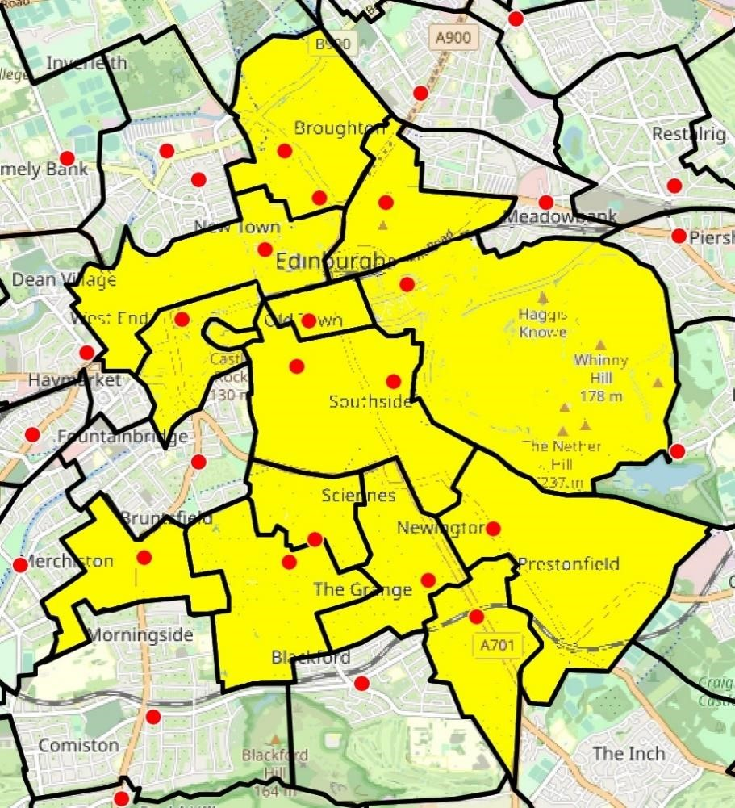

PARISHES
- Canongate, High Kirk St Giles’
- Greyfriars, St Cuthbert’s
- Broughton St Mary’s, Greenside, St Andrew’s and St George’s West
- Craigmillar Park, Mayfield Salisbury, Priestfield,
- Marchmont St Giles’, Morningside United, St Catherine’s Argyle
Population of parishes 131,126
Average population of Parish 14,958
Number of Posts Ministers 8
MDS 1

Mission Narrative for Mission District B Central

A rich tradition of history and community engagement is mixed with a clear recognition of, and response to, contemporary issues. Congregations in this district have welcomed thousands of tourists and visitors, offered space for concerts and choirs, enriched the city with their history and offered a variety of worship. Yet the homeless and outcast have been cared for, the LGBTQ+ community has been engaged with, Christian Aid has been supported, students have been welcomed and the elderly supported. Some of the congregations in this Mission District are strong and healthy while others are clearly struggling with buildings, finances and/or numbers. Cluster discussions, as well as informal conversations, have paved the way for these congregations to provide a vibrant heartbeat of mission from the Centre of the City.

The following is therefore proposed:

- Mission District B will be served by eight FTMWS, two Presbytery funded posts (one Theatre Post and one Pioneer Minister) and local staff as necessary by the end of the plan. This mission district also includes one minister as part of a Local Ecumenical Partnership.

- Canongate and High St. Giles’ will be served by two FTMWS, with one focused on city-wide responsibilities. The ministers, as well as local staff, will share worship and pastoral care. The presence of two congregations on the Royal Mile offering a faith presence for tourists, civic leaders and others argues that both buildings be retained.

- Greyfriars and St. Cuthbert’s will be served by one FTMWS and local staff as necessary. The well-established outreach at Greyfriars can complement mission initiatives at St. Cuthbert’s.

- Broughton St. Mary’s, Greenside and St. Andrew’s and St. George’s West will be served by two FTMWS, a 0.5 Ministry to the Theatres post and local staff. Discussions regarding the future of Broughton St. Mary’s building should begin as a matter of urgency given fabric costs. The commitment to the theatres will continue and will complement the wider mission of the parish.

- Craigmillar Park, Mayfield Salisbury and Priestfield will be served by two FTMWS and local staff as necessary. The energy of Priestfield, the combination of stability and mission orientation at Mayfield Salisbury and the opportunities afforded by the building at Craigmillar Park will strengthen mission in the area.

- Marchmont St. Giles’, Morningside United and St. Catherine’s Argyle will be served by one FTMWS, one Pioneer Minister to the Under 40s, one Minister from the Local Ecumenical Partnership and local staff. The community Centre feel to Marchmont St. Giles’ will be complemented by the formal ecumenical link, and the focus on the younger generations at St. Catherine’s Argyle provide a springboard for outreach to the Under 40s and will balance the care of the elderly.

Cluster C – NORTH

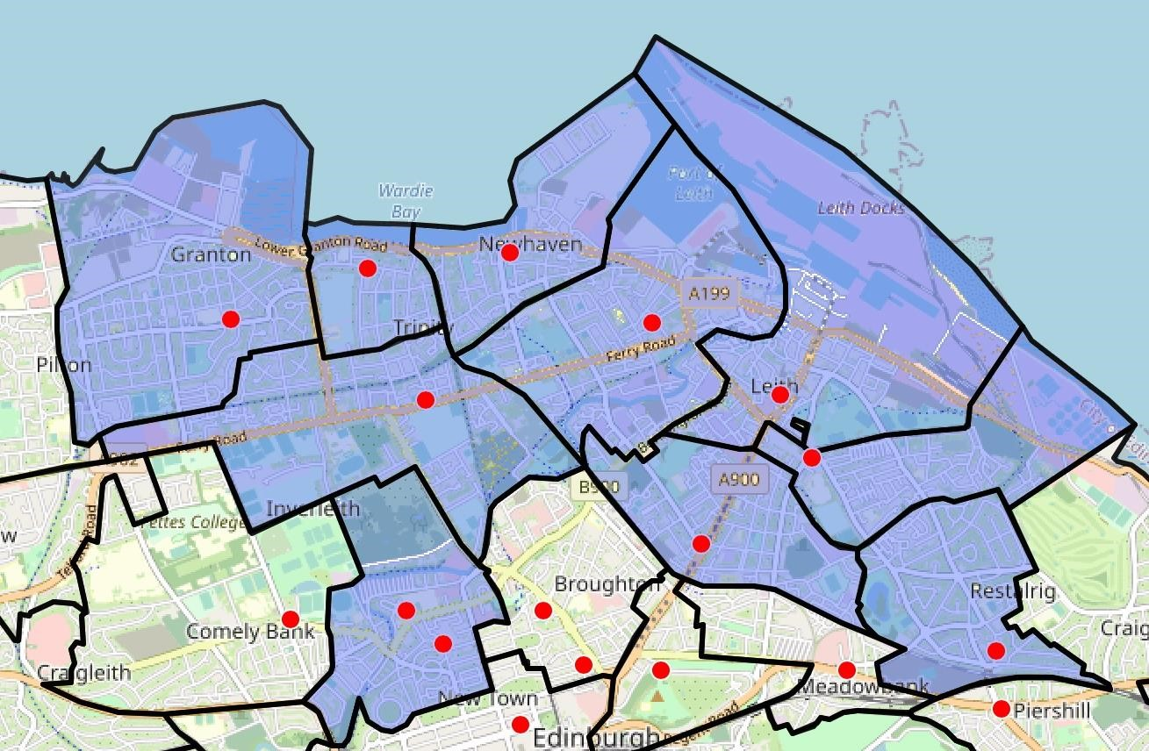

PARISHES
- Granton, Wardie
- Inverleith St Serf’s, Stockbridge
- Leith North, Leith South, Newhaven
- Leith St Andrew’s, Pilrig St Paul’s, St Margaret’s
Population of parishes 89,482
Average population of Parish 22,370
Number of Posts Ministers 5
MDS 1

Mission Narrative for Mission District C North

Geographical proximity, shared interests and complementary gifts and skills mark this Mission District. Some congregations are set within areas of noticeable need whilst others are located in areas of abundance. Small parishes are connected with larger parishes. There are congregations that have worked together for years and others that have only more recently begun to interact with each other. Some share a keen interest in environmental matters, one of the Five Marks of Mission, others have been looking to consolidate and focus their outreach to the Leith community, and others have used, and are planning to use, their buildings in new and creative ways. The combination of well-established relationships with new connections will create a mission dynamic.

The following is therefore proposed:

- Mission District C will be served by five FTMWS, one Pioneer MDS and local staff as necessary.

- Granton and Wardie will be served by one FTMWS and local staff. Granton is set in an area of some need and has reached out with enthusiasm and effectiveness. Wardie, currently the smallest parish in Edinburgh Presbytery, has an outward orientation combined with resources. Both congregations have focused on environmental issues (the fifth Mark of Mission), one of the threads which can help to foster effective mission.

- Leith North, Leith South, and Newhaven will be served by two FTMWS and local staff. Leith North and Leith South have been part of wider conversations regarding mission in Leith and have some shared connections with Newhaven.

- Leith St. Andrew’s, Pilrig St. Paul’s and St. Margaret’s will be served by one FTMWS and one Pioneer MDS. Leith St. Andrew’s and Pilrig St. Paul’s have been engaged in ongoing conversations regarding mission in Leith and St. Margaret’s shares an area with similar needs.

- Inverleith St. Serf’s and Stockbridge will be served by one FTMWS. Both congregations are currently vacant, and both have used their facilities in imaginative and creative ways to reach out to the community. The shared experiences can and will spark further mission ideas and possibilities. Prior to the vacancies, the ministers had already begun working together and a continuation of this trajectory will help to steer mission into the future.

Cluster D – WEST
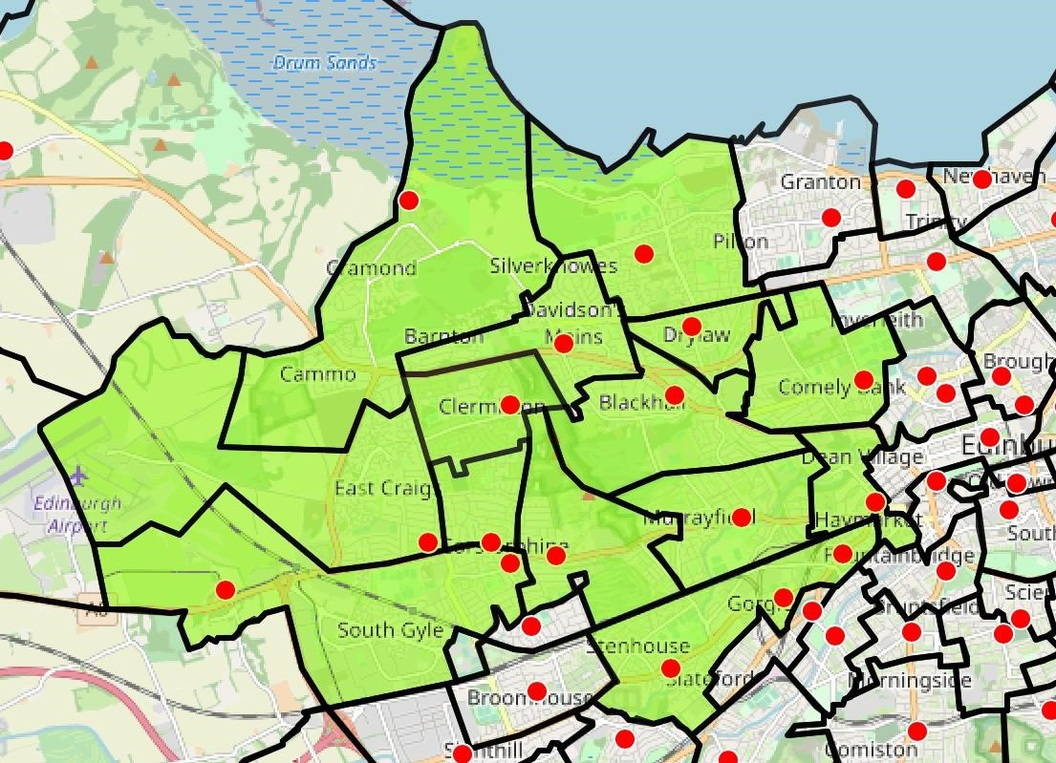

PARISHES
- Corstorphine St Anne’s, Murrayfield
- Gorgie Dalry Stenhouse, Palmerston Place
- Corstorphine St Ninians, St Andrew’s Clermiston
- Cramond, Drylaw, The Old Kirk & Muirhouse
- Blackhall St Columba’s, Davidson’s Mains,
St Stephen’s Comely Bank
- Corstorphine Old, Corstorphine Craigsbank
Population of parishes 113,736
Average population of Parish 18,956
Number of Posts Ministers 8
MDS 3

Mission Narrative for Mission District D West

This Mission District connects several congregations that have previously been in conversations before, yet now does so in a manner that will encourage a focus on outward and new mission. Again, previous connections between congregations will strengthen mission within the Mission District. Stable and secure congregations are asked to work alongside those that have been struggling. Congregations that have long focused on outreach, whether to the homeless or the poor, are now encouraged to work more closely with neighbouring congregations to fulfil the call to serve. An outward orientation calls on these congregations to look to those in their midst, to those who are struggling neighbours and those who are on the periphery, set in an environment that may lack amenities or support, both human and material. Looking outward, this Mission District will bless many near and far with the abundance of their gifts.

The following is therefore proposed:

- Mission District D will be served by seven FTMWS, one Pioneer Minister, one Deacon, one Full-Time MDS, two-Part Time (0.5) MDS and local staff. Given the concentration of buildings in this area, as well as the costs required for maintenance, in depth conversations regarding future retention are urgently required.

- Murrayfield and Corstorphine St. Anne’s will be served by one FTMWS and 0.5 MDS. Both congregations are strong and stable. Because both have been outward orientated, this direction of travel is to be encouraged within their locale to use their noticeable gifts for mission near and far.

- Gorgie Dalry Stenhouse (GDS) and Palmerston Place will be served by one FTMWS and local staff as necessary. GDS are currently in vacancy and yet have continued a strong outward focus. Palmerston Place has a tradition of good governance coupled with a proud history of hospitality to local groups and a mission orientation. Outreach to the homeless is now a theme common to both. Decisions regarding buildings are important to steward resources wisely for the sake of mission.

- Corstorphine St. Ninian’s and St. Andrew’s Clermiston will be served by one FTMWS and one 0.5 MDS. The combination of the gifts of St. Ninian’s and St. Andrew’s current outreach will provide an impetus for effective mission.

- Cramond, Drylaw and The Old Kirk Muirhouse (TOKM) will be served by one FTMWS, one Deacon, one MDS and local staff. Connections already made between these congregations will be further strengthened by working more formally together. The release of manses will help to fund current ideas mooted for a more effective mission presence in the Muirhouse area.

- Blackhall St. Columba’s, Davidson’s Mains and St. Stephen’s Comely Bank will be served by two FTMWS and local staff as necessary. All three congregations possess buildings in good repair. The stability and strength of Blackhall St. Columba’s and the mission energy of Davidson’s Mains
will complement the work at St. Stephen’s Comely Banks as it forges a future with revamped premises.

- Corstorphine Craigsbank and Corstorphine Old will be served by one FTMWS, one Pioneer Minister and local staff as required. Urgent discussions are required for both churches due to cost of upkeep and/or location. Mission ideas are in good supply; however, and thus the congregations are called to continue mission in the workplaces and East Craigs, but turn their skills and experience to the new builds to the west.

Cluster E – EAST
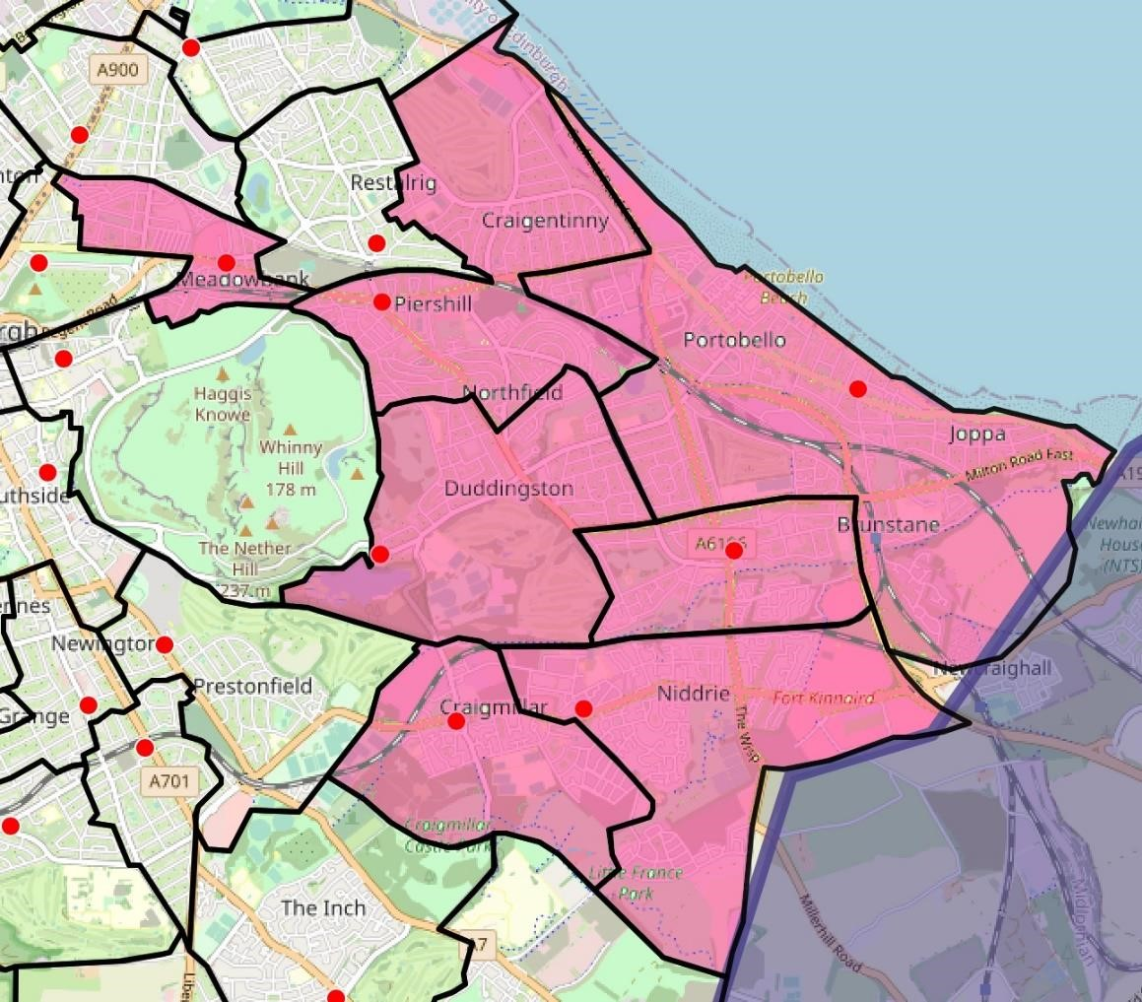

PARISHES
- Meadowbank, Portobello and Joppa, Willowbrae
- Bristo, Duddingston, Richmond Craigmillar, St Martin’s
Population of parishes 56,384
Average population of Parish 28,192
Number of Posts Ministers 5
MDS 1

Mission Narrative for Mission District E East

This Mission District combines congregations with a variety of histories and a variety of connections. Congregations that have had a long, stable history are asked to work with those that have seen significant change in the recent or less recent past. Congregations that know each other well, whether historically or through recent discussions, can now widen their horizon with more in depth imagining with others. Placing these congregations within a single mission district creates a framework in which the mission work that is currently done in a variety of settings can stimulate new and fresh thinking. Caring for those who struggle, whether with mental health or bereavement, is set alongside the reaching out to younger generations, the unchurched and local community groups. Established relationships and faithful experience, combined with fresh and wider perspectives, will allow this mission district to widen and deepen its mission commitment.

The following is therefore proposed:

- Mission District E will be served by four FTMWS, one Pioneer Minister, one MDS and local staff. Current and forthcoming vacancies should prompt in-depth discussions regarding the release of buildings in order to allow a faithful stewardship of resources and a focus on mission.

- Meadowbank, Portobello, and Joppa Parish Church (PJPC) and Willowbrae will be served by two FTMWS and one MDS. The combination of lively outreach at Meadowbank, the strength and stability at PJPC and the consolidation at Willowbrae will complement the mission work along the A1 corridor.

- Bristo Memorial, Duddingston, Richmond Craigmillar (a Priority Area with double weighting for posts) and St. Martin’s will be served by two FTMWS and one Pioneer Minister. Cluster conversations have strengthened connections amongst these congregations and the vacancy at Bristo Memorial allows scope for further possibilities. Serving areas with significant need, including one of only two Priority Areas in Edinburgh, will help focus the mission in this area, combining current mission with new ideas. With changes imminent at Bristo Memorial, decisions regarding suitable buildings should be made timeously.

Cluster F – SOUTH
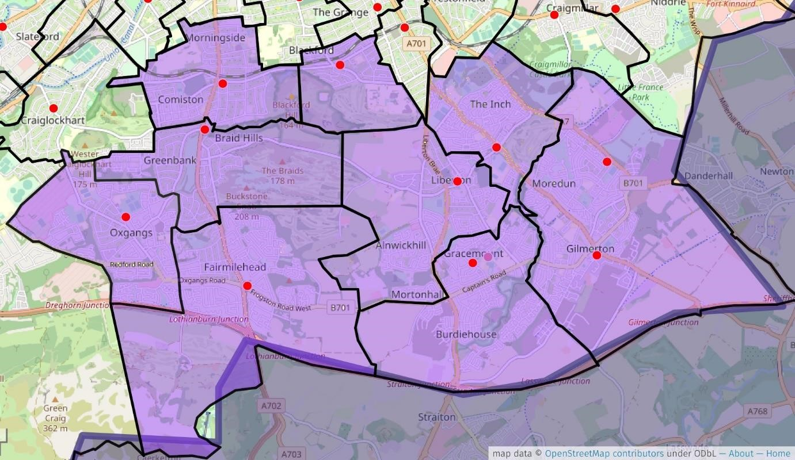

PARISHES
- Gracemount, Liberton, Liberton Northfield, Tron Kirk Gilmerton Moredun
- Morningside, Reid Memorial
- Fairmilehead, Greenbank, St John’s Colinton Mains
Population of parishes 73,146
Average population of Parish 24,382
Number of Posts Ministers 5
MDS 1

Mission Narrative for Mission District F South
This Mission District is marked by the juxtaposition of churches set in areas of affluence, churches set in areas of socio-economic challenges and areas seeing the construction of new housing. Major arteries radiating from the centre of Edinburgh southwards create corridors along which travel is possible and connections made. The congregations in this cluster have used churches, halls and manses for imaginative mission, and the sharing of insights gained from these experiences across the district will assist in missional effectiveness. Support for the worldwide church is set alongside selfless and sacrificial support for local people struggling with the pressures of modern life. Such outward looking perspectives will assist in the mission to the new housing being built in the district.
The following is therefore proposed:
- Mission District F will be served by five FTMWS, one MDS and local staff as needed. Many of the buildings are in excellent condition and these can provide bases and meeting points for mission within the new congregations and across the district.
- Gracemount, Liberton, Liberton Northfield and Tron Kirk Gilmerton, Moredun will be served by two FTMWS and one Pioneer MDS. These congregations have worked well together over many years with all ages and the outreach, creativity and mission can be consolidated by working as a single entity. A church plant in the new housing can be undertaken with the knowledge and experience gained from current initiatives.
- Morningside Parish Church and Reid Memorial will be served by one FTMWS and local staff as required. Recent refurbishment at Morningside has underlined the potential of buildings used wisely for hospitality, the hosting of community groups and the forging of relationships. Lessons learnt from this process, shared with the congregation of Reid Memorial, can point the way to the best missional use of Reid Memorial’s buildings. The sale of the Reid Memorial manse can provide funds to undertake this or related missional initiatives guided by good organisation and governance.
- Fairmilehead, Greenbank and St. John’s Colinton Mains (SJCM) will be served by two FTMWS and local staff as required. All these congregations host a variety of community groups and within their complexes outreach is undertaken. As SJCM proceed with a refurbishment of their site, support from the other churches can help draw the congregations closer. Fairmilehead and Greenbank, congregations located in areas with noticeable resources, can work in partnership with SJCM, located in an area with more socio-economic challenges. Mission and outreach will thus stretch from the local hall and the local area to the wider city and further afield.

Cluster G – BORDER
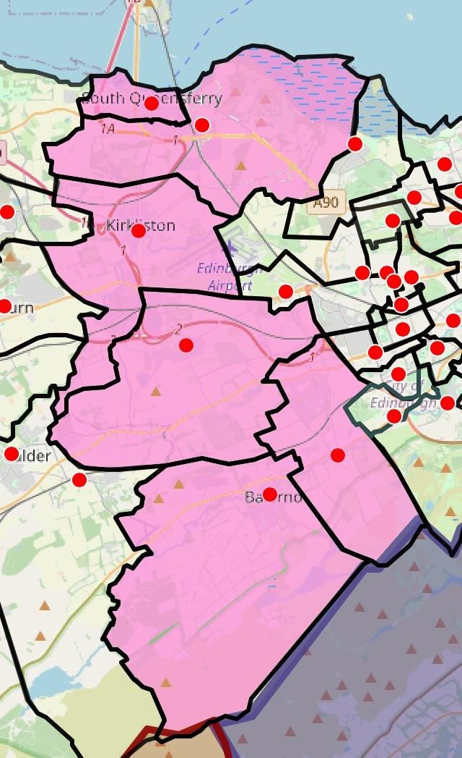

PARISHES
- Dalmeny, Queensferry
- Kirkliston, Ratho
- Balerno, Currie
Population of parishes 36,301
Average population of Parish 12,100
Number of Posts Ministers 3
MDS 0

Mission Narrative for Mission District G Border

This Mission District combines several parishes with a distinct rural character and several towns within an area seeing much growth. The rich history of the churches and parishes in this area has provided a basis for mission and outreach that is new and relevant. Cafes, youth workers, Messy Church, concerts, and other activities complement traditions and traditional settings that draw many into an area of natural beauty on the western fringe of the city. West Lothian sits just beyond the border of this Mission District and thus partnership with these parishes will allow more effective mission in a changing environment.

The following is therefore proposed:

- Mission District G will be served by three FTMWS and local staff as necessary. The presence of small, rural churches, though attractive and of historical significance, require proportionally significant resources to maintain. Conversations regarding their use for mission in current circumstances are of vital importance.

- Dalmeny and Queensferry will be united into one congregation served by one FTMWS. The current mission initiatives of both, as well as their effectiveness, can inform conversations with parishes in the current West Lothian Presbytery. Discussions regarding buildings may be required as the framework of the new Presbytery and the Mission Districts within it become clearer.

- Kirkliston and Ratho will be served by one FTMWS and local staff as required. Current mission programmes can be a catalyst for further work along the canal, tying together mission within Edinburgh and at its western edge. New housing too will present opportunities for mission. In due course, serious conversations about buildings will be needed given finances as well as the age and character of the buildings.

- Balerno and Currie will be served by one FTMWS and local staff as required. Both congregations have undertaken excellent mission work. This commitment should form the basis of earnest conversations about the buildings required both in terms of location and suitability for mission. Imminent changes regarding the boundaries and composition of the new united Presbytery will mean discussions with neighbouring West Lothian parishes are a priority.

Mission District A – South West

1 Union of Colinton - Juniper Green - Slateford Longstone

FUTURE NATIONAL POSTS |  | Two Ministers
LOCAL PROVISION |  | Colinton – part time Pastoral Worker and part time Family Worker
MANSES |  | Colinton to be sold.
 |  | Juniper Green to be sold.
 |  | Slateford Longstone to be sold.
 |  | Purchase two new manses.
CHALLENGE |  | Consider future of Colinton building.  Bring the three worshipping communities together and establish clear priorities.
ADJUSTMENT |  | The demission of a Minister or by the ending of the Reviewable Charge of Slateford Longstone no later than December 2025.
TENURE |  | tbd
MISSION |  | The three worshipping communities must work together to deliver Ministry and Mission in all three areas with two Ministers.  Slateford Longstone is a Reviewable Charge. Each will have to work together to develop a new joint vision and to share the challenges.
FINANCES |  | Colinton are liberal, but there has been a downward trend in income and per capita giving could be improved.  Juniper Green’s income has fluctuated but is generally stable.  Slateford Longstone’s finances are stable for its demographic.
THE CHURCH BUILDING |  | Colinton is an old parish church but, according to the building
toolkit, ‘is no longer in the heart of the community’. Car parking ‘is an issue’ according to the toolkit, which also suggests not inconsiderable costs for maintenance and repair.
Juniper Green is accessible from Lanark Road but the ramp ‘is a little too steep to be fully compliant’. Is it in the correct location? Because many families reside in Baberton Mains, it would be ‘ideal’ to ‘have a satellite building…to ensure we are engaging with that community…’

Slateford Longstone is expensive to heat ‘because of the size’ and is
‘only set for Sunday service and occasional special services.’

2 Union of Holy Trinity (Priority Area) - St Nicholas Sighthill
FUTURE NATIONAL POSTS |  |  | Two Ministers
LOCAL PROVISION |  |  | Holy Trinity – OLM and Youth Worker.
FUTURE LOCAL POSTS |  |  | OLM for St Nicholas Sighthill.
MANSES |  |  | St Nicholas to be sold and a new manse purchased.
CHALLENGE |  |  | The challenge is to consider if either building is fit for purpose and whether a new build is the way forward? There is a significant potential to work with children and families. Consider working with Ratho and Polwarth on the canal boat project.
TENURE |  |  | tbd
MISSION |  |  | Holy Trinity is a Priority Area and has a double weighting of posts.  There are common themes and challenges in the two parishes. Working together should provide a coherent and supportive framework for Ministry and Mission in the area. The delivery of Ministry to the Poor must be prioritised and different Mission initiatives should be considered as a priority.
FINANCES |  |  | Holy Trinity are generous givers.  St Nicholas Sighthill has many challenges, and income has been on a downward trend. It is below the Ministries and Mission benchmark to support a minister.
CHURCH BUILDINGS |  |  | Holy Trinity’s needs to be considered: ‘further expansion of
ministries and community outreach is limited due to building footprint limitations.’
St Nicholas Sighthill’s need to be considered. It has had significant fabric issues, which have been addressed, but the future sustainability must be considered alongside future needs (‘we could do with more space’).

3 Union of Carrick Knowe - St David’s Broomhouse
FUTURE NATIONAL POSTS One Minister and 0.5 MDS
LOCAL PROVISION |  |  | Carrick Knowe - 0.5 Children’s Worker.
MANSES |  |  | One manse to be sold.
CHALLENGE |  |  | Bring both congregations and parishes together to share a joint vision for the Mission to both parishes. Work with young people and the Corstorphine Dementia Project. Carrick Knowe to explore its Stewardship and make a concerted effort to increase Ministries and Mission Contributions.
ADJUSTMENT |  |  | The demission of a Minister or by the ending of the Reviewable  Charge of St David’s Broomhouse no later than December 2025.
TENURE |  |  | tbd
MISSION |  |  | A priority for the new parish is to build on the good practice of the past and to incorporate two different congregations into one which can support and encourage each other. Clear priorities must be identified.
FINANCES |  |  | Carrick Knowe is currently stable although their per capita giving must be improved to address the issue that the income is below the Ministries and Mission benchmark to support a minister.  St David’s Broomhouse faces significant challenges, with a recent noticeable decline in income. It is below the Ministries and Mission benchmark to support a minister.
CHURCH BUILDINGS |  |  | There are issues with the Jubilee Hall, ‘but any further major repairs
would not be economically sensible’. There is good parking.
St David’s Broomhouse has issues. The buildings are currently in an acceptable state of repair: the ‘cost of maintenance and repair has always been a challenge for the Kirk Session and Congregation’. There are problems with water ingress. There is limited internal flexibility. There is an adjacent community space which has ‘undergone a multi-million-pound redevelopment.’
Future in depth discussions regarding the future use of the building should be initiated.

4 Union of Barclay Viewforth - Craiglockhart- Polwarth – St Michael’s
FUTURE NATIONAL POSTS |  |  | Two Ministers
LOCAL PROVISION |  |  | Craiglockhart – Youth Worker.
MANSES |  |  | Barclay Viewforth manse to be retained.
 |  |  | Craiglockhart to be sold.
 |  |  | Polwarth to be sold.
 |  |  | St Michael’s to be retained.
CHALLENGE |  |  | Work with Ratho, and other relevant parishes, in Edinburgh and  West Lothian, on the Canal Boat Project.  Barclay Viewforth Congregation to be planted in Morningside United building. There will need to be in-depth conversations with the United Reformed Church and the Ecumenical Relations Committee of the Church of Scotland about the future of the Local Ecumenical Partnership in this area.
ADJUSTMENT |  |  | The demission of a Minister or by the ending of the Reviewable  Charge of Polwarth or St Michael’s no later than December 2025.
TENURE |  |  | tbd
MISSION |  |  | This reconfiguration will combine parishes on both sides of the canal. We are asking the congregation to grasp a missional opportunity to build a ‘bridge’ and come together for a new future. The current congregations have different experiences and challenges within their respective parishes. The new parish must work to agree priorities for the future; to decide what will end and what must start afresh; and to identify clear priorities. The Polwarth part of the parish is challenged to deliver a floating Ministry on the canal.
FINANCES |  |  | Barclay Viewforth’s are relatively stable although 2020 was a
 |  |  | challenging year for them.
Craiglockhart’s are showing signs of a downward trend.
Polwarth’s income and expenditure has fluctuated.
St Michael’s provide cause for concern with several recent years
 |  |  | running in deficit.
CHURCH BUILDINGS |  |  | Barclay Viewforth has no ‘compliant second means of escape from
first floor gallery in church and from main hall’; requires significant
outlay for maintenance, repairs, and energy, as well as ‘significant repairs being required’; and there is ‘no disabled parking space close by’.
Craiglockhart has required significant outlay in maintenance and repairs, there is no ‘on-site parking’ and crossing the busy road ‘is somewhat daunting for the elderly and less fit.’
Polwarth had significant work done in the recent past. There is very limited parking.
St Michael’s has spent significant sums for maintenance and repair
given its deficits; requires safety work to be carried out and has limitations in accessibility; the pews could be considered ‘restrictive’; and the lack of a school and care home in the Parish ‘curtail[s] its reach into the community’.

Mission District B – CENTRAL

1 Union of Canongate - High St Giles’
FUTURE NATIONAL POSTS Two Ministers – one with city-wide missional responsibilities
LOCAL PROVISION High St Giles’ – Associate.
MANSE Canongate manse to be retained.
High St Giles’ manse to be retained.
CHALLENGE The challenge is to address the many challenges which come with a city centre parish: tourism/pilgrimage; night economy; Armed Services community; musical community; and ecumenical working.
ADJUSTMENT The demission of a Minister or by the ending of the Reviewable Charge of Canongate to end no later than December 2025.

TENURE tbd
MISSION City centre ministry in the Royal Mile reaches large numbers of
tourists and those who attend concerts and events within the buildings. However, there are very few congregants who live in the city centre parishes and the worshipping community is made up of a gathered group of people and tourists.
The issue is whether the Church of Scotland requires two places of worship in the Royal Mile. The consensus is that currently it is important to retain both buildings. The united parish must decide how to deliver ministry and mission to the best advantage and by using streaming and social media to aid this.
The proposal is to make changes to the tenure of Canongate. The current Minister of Canongate will deliver a city-wide Ministry to the
Parliament, Council and Armed Forces communities. The Minister of Canongate will continue to reside in the manse. He will also be responsible for the delivery of worship and pastoral care, in its various forms, in the new parish, in partnership with the former High St Giles’ Parish.
The Parish Minister of High St Giles’ and the Associate will also share in the delivery of mission, worship, and pastoral care at Canongate.
The expectation will be that the current Minister of Canongate will share in the delivery of worship at High St Giles’.
FINANCES | High St Giles’ cause significant concern: they are urged to make every effort to fulfil their commitments.  Canongate do not present an immediate cause for concern although they have run at a deficit in recent years.
CHURCH BUILDINGS | High St Giles’ is historic and is exercised by the cost of the partial insurance of the building, which is exorbitant. Consideration must be given to releasing the building to Historic Environment Scotland and a conversation with them is required to consider all possible options.
Canongate is light, airy and historic and the ongoing maintenance is sustainable.

2 Union of Greyfriars - St Cuthbert’s
FUTURE NATIONAL POSTS |  |  | One Minister
LOCAL PROVISION |  |  | Greyfriars – two 0.5 posts.
MANSES |  |  | Greyfriars to be retained.  St Cuthbert’s manse to be retained for the use of the Edinburgh Pioneer Minister to the under 40s.
CHALLENGE |  |  | The city centre parishes already have ministries to homeless people. The Gaelic community is already part of Greyfriars. The night economy is an excellent mission to engage in and tourism is an important part of both parishes. Ecumenical working is already embedded in the mission of both parishes and is commended.
ADJUSTMENT |  |  | The demission of a Minister or by the ending of the Reviewable Charge of St Cuthbert’s no later than December 2025.
TENURE |  |  | tbd
MISSION |  |  | City centre ministry reaches large numbers of tourists and those who attend concerts and events within the buildings. There are very few congregants who live in the city centre parishes and the worshipping community is made up of a gathered group of people and tourists.  Greyfriars has many examples of delivery of mission to the city centre and to vulnerable people. St Cuthbert’s delivers ministry to the homeless and is a well-used space. St Cuthbert’s and Greyfriars have many areas of mission in common and can best deliver the Gospel as a union.
FINANCES |  |  | Greyfriars’ are stable.
 |  |  | St Cuthbert’s present significant concern due to deficits.
CHURCH BUILDINGS |  |  | St Cuthbert’s requires vigilance and care, and a significant expense has been incurred, both in maintenance and utilities and in upgrading their sanctuary, which is attractive and ‘more useable’.
Greyfriars is fit for purpose.

3 Union of Broughton St Mary’s – Greenside – St Andrew’s and St George’s West

FUTURE NATIONAL POSTS Two Ministers
LOCAL PROVISION Greenside – 0.5 theatre post.
MANSES Broughton St Mary’s to be retained.

St Andrews’ and St George’s to be retained.

CHALLENGE The parish is to work together to deliver Work Place Chaplaincy
Scotland (WPCS); city centre specific ministry; ecumenical and interfaith working; and work with the LGBT community. Clear priorities must be identified.
Broughton St Mary’s are to be commended for their good working interfaith relationship with the local mosque.
ADJUSTMENT Greenside Guardianship to end.
NEW POSTS OLM

TENURE tbd
MISSION City centre ministry reaches large numbers of tourists and those
who attend concerts and events within the buildings. There are very few congregants who live in the city centre parishes and the worshipping community is made up of a gathered group of people and tourists.

The new parish must find a way to work together to deliver ministry and mission to these small parishes, the daytime population of which significantly increases during the week.
One focus must be on the workplace and on the large numbers of people who work in theatres and go to them. Clear priorities must be identified.

FINANCES Broughton St Mary’s rely heavily on hall usage to support a
worshipping congregation of 48 (2019 estimate) and the giving is not that liberal.
Greenside have been liberal, but recent years have been marked by deficits. It is below the Ministries and Mission benchmark to support a minister.
St Andrew’s and St George’s West are liberal; however, recent years have been marked by deficits.

CHURCH BUILDINGS Broughton St Mary’s has challenges in a number of areas: facilities (‘One small toilet. No disabled access’ at the sanctuary level); parking (‘a single parking space…one must drive across the pavement to reach it’, pay and display and ‘a car park at the local supermarket which is 0.3 mile away’); viability (the ‘imposing’ façade ‘may be a deterrent to attracting some new worshippers’) and belonging (intention to engage more fully with users ‘has not been fully developed.’).
Future in depth discussions, regarding the future use of the building should be initiated.
Greenside has recently required work due to water ingress and has ‘only limited accessibility’ but ‘there are a number of opportunities’ for partnership and the development potential of the halls ‘is considerable.’
St Andrew’s and St George’s West is well maintained but with some challenges about dedicated disabled parking. City Centre parking is a real challenge.

4 Union of Craigmillar Park - Mayfield Salisbury – Priestfield

FUTURE NATIONAL POSTS Two Ministers
LOCAL PROVISION Mayfield Salisbury - one Youth Worker – one Pastoral Worker.
MANSES Craigmillar Park to be sold.
Mayfield to be retained.
Priestfield to be retained.
CHALLENGE There is a significant amount of work amongst students, children,
and with older people. Clear priorities to be identified. A challenge will be to coordinate all the work and to share gifts and abilities.
ADJUSTMENT The demission of a Minister or by the ending of the Reviewable
Charges of Craigmillar Park (l/w Reid Memorial) and Priestfield no later than December 2025.

TENURE tbd
MISSION The current congregation of Mayfield Salisbury has many resources
and people with gifts who can work across the wider area.
The resourcefulness and energy of Priestfield is commended. It is
recognised that the most vulnerable part of the area sits within the current Priestfield parish and that resources should be given. The new parish should work together to support older people, students in the Pollock Halls and the many children who live in the area. Clear priorities need to be identified.
FINANCES Craigmillar Park is ‘declining in size and therefore income’, with several years of deficits.
Mayfield’s are liberal.
Priestfield are liberal givers and income has increased slightly in the last three years while expenditure has decreased.

CHURCH BUILDING Mayfield is fit for purpose.
Craigmillar Park Church is accessible and well maintained but must improve accessibility and flexibility.
Priestfield require ‘loan facilities’ for large fabric items and has
significant accessibility issues. Viability too is an issue: potential for growth is ‘limited by size’.

5 Union of Marchmont St Giles’ - Morningside United - St Catherine’s Argyle
FUTURE NATIONAL POSTS |  | One Minister  Morningside United is a Local Ecumenical Partnership between the Church of Scotland and the United Reformed Church. The ministry post at MUC is not technically part of the Edinburgh Presbytery Plan but we recommend that discussions open immediately with the URC and the Ecumenical Relations Committee of the Church of Scotland on the future of the LEP.
FUTURE PRESBYTERY POST |  | One Pioneer Minister to Under 40s to cover whole city.
LOCAL PROVISION |  | Marchmont St Giles’ – one Families Worker – one Reader.
MANSES |  | Marchmont St Giles’ to be sold.
 |  | Morningside United to be retained.
 |  | St Catherine’s Argyle to be sold.
 |  | A new manse to be purchased.
CHALLENGE |  | Review the future of the Local Ecumenical Partnership. Student, children and young people, older people ministry, ecumenical work with the new parish
ADJUSTMENT |  | The demission of a Minister or by the ending of the Reviewable Charge of St Catherine’s Argyle no later than December 2025.
TENURE |  | tbd
MISSION |  | This new parish is the area of Edinburgh with the highest proportion of elderly people: it also has six nursing homes and one retirement complex. The parish has responsibility for some of the Chaplaincy at Napier University. There are also many children in the area.  The membership of the congregation is stable, if not growing.
FINANCES |  | Marchmont St Giles’ are liberal.
Morningside United have had deficits in the last five out of seven years.
St Catherine’s Argyle have seen declining income with significant costs and do not meet the Ministries and Mission benchmark to pay for a Minister.

CHURCH BUILDINGS St Catherine’s Argyle presents significant fabric concerns in the following areas: the effects of wind and water; the ability to afford ongoing maintenance and repair (‘we need to reassess our long-term strategy for funding and fabric works’); accessibility (‘it is possible to navigate most but not all halls and rooms’); and viability (‘It is difficult to say whether the location suits worshippers’).

Mission District C – NORTH

1 Union of Granton - Wardie
FUTURE NATIONAL POSTS |  |  | One Minister
LOCAL PROVISION |  |  | Granton - 0.8 Outreach Worker – Wardie – 0.5 Families Worker.
MANSES |  |  | tbd
CHALLENGE |  |  | The new congregation must envision ways to continue to support the various current mission projects.
ADJUSTMENT |  |  | The demission of a Minister or by the ending of the Reviewable Charge of Granton no later than December 2025.
NEW POSTS |  |  | OLM
TENURE |  |  | tbd
MISSION |  |  | Wardie is a small parish but has gifts and resources which could support and encourage the parish of Granton, which has significant challenges and areas of need. They must seek to work together and share ministry resources, including people, to ensure the delivery of the ordinances of religion and mission to the most vulnerable.
FINANCES |  |  | Granton has been prudent but pay below the Ministries and Mission benchmark.  Wardie’s are liberal, though with recent decreases in income and expenditure.
CHURCH BUILDINGS |  |  | Granton has had money spent on it due to water ingress, but an eye needs to be kept on the property. This suggests that in future a decision might need to be made on the building of Granton.
 |  |  | Wardie is wind and watertight, though flexibility could be
 |  |  | improved.

2 Union of Leith North - Leith South - Newhaven
FUTURE NATIONAL POSTS |  |  | Two Ministers
LOCAL PROVISION |  |  | Newhaven – one Families Worker.
MANSES |  |  | tbd
CHALLENGE |  |  | Consideration must be given to selling all church buildings and developing a hub church to serve community.
ADJUSTMENT |  |  | The demission of a Minister or the ending of the Reviewable Charges of Leith North and Leith South no later than December  2025.
NEW POSTS |  |  | OLM
TENURE |  |  | tbd
MISSION |  |  | One church for Leith has been a long-term plan for the area. With changes in accessibility to the buildings in Leith, it should not be assumed that the Leith South building should be retained.  Significant conversations must take place about how best to deliver ministry and mission to this new parish. Clear priorities should be identified. The new parish, in this vibrant area of Edinburgh, must work together to share the Gospel to its diverse people, businesses, and developments.
FINANCES |  |  | Leith North have experienced five out of seven years of deficits.
 |  |  | Leith South have experienced five years out of six years of deficits
 |  |  | Newhaven’s are stable. The congregation give generously.
CHURCH BUILDINGS |  |  | Leith North has issues with accessibility, flexibility, and viability.
 |  |  | Leith South location ‘is not as visible as it could be’. It is wind and
 |  |  | watertight.

3 Union of Leith St Andrew’s - Pilrig St Paul’s - St Margaret’s

FUTURE NATIONAL POSTS One Minister and one Pioneer MDS LOCAL PROVISION
HALLS |  |  | St Margaret’s halls could be refurbished, and the congregation need to use the space to increase income.
MANSES |  |  | Leith St Andrew’s to be sold.  Pilrig St Paul’s to be sold.  St Margaret’s to be retained.
CHALLENGE |  |  | Priority to the Poor.
ADJUSTMENT |  |  | The demission of a Minister or the ending of the Reviewable Charges of Leith St Andrew’s, Pilrig St Paul’s and St Margaret’s no later than December 2025.
NEW POSTS |  |  | OLM
TENURE |  |  | tbd
MISSION |  |  | One church for Leith has been a long-term plan for the area. Significant conversations must take place about how best to deliver ministry and mission to this new parish. The parish of St Margaret’s has a significant area of deprivation and resources should be concentrated in this area of mission. The delivery of mission to the businesses of the area must also be discussed and implemented.  The Pioneer Post would work to develop outreach and projects for the poor in the area.
FINANCES |  |  | Leith St Andrew’s has had deficits for the last three years.  Pilrig St Paul’s has had deficits for five out of the last seven years. The per capita givings are low. The congregation pay below the Ministries and Mission benchmark for a Minister.  St Margaret’s has had deficits for six out of the last seven years. The congregation just about contributes enough Ministries and Mission Contributions to meet the cost of a Minister.
CHURCH BUILDINGS |  |  | Leith St Andrew’s is sustainable now. “In the short term the costs are
sustainable but longer-term budgeting may be different”. Accessibility and parking are a concern, as is flexibility (‘the church ‘is only used once a week’).

Pilrig St Paul’s ‘doesn’t offer much flexibility in how it can be used’ and has accessibility issues (the main hall ‘is not accessible to all’).

St Margaret’s is situated in a village/graveyard setting with a “low footfall” and is not convenient for public transport.

4 Union of Inverleith St Serf’s and Stockbridge
FUTURE NATIONAL POSTS |  | One Minister
LOCAL PROVISION |  | Inverleith St Serf’s Community Outreach Worker.
MANSE |  | Stockbridge to be sold.  Inverleith St Serf’s to be retained.
CHALLENGE  ADJUSTMENT  NEW POSTS |  | Bring the two congregations together and identify a united strategy for delivering mission and ministry to the area.
TENURE |  | tbd
MISSION |  | The new congregation will benefit from the combined experiences and develop strengths and talents. Setting priorities will be important.
FINANCES |  | Inverleith St Serf’s are healthy.  Stockbridge’s are a cause of concern and have run a deficit in five of the last seven years.
CHURCH BUILDINGS |  | Inverleith St Serfs has had a recent refurbishment and is in good condition.
 |  | Stockbridge is accessible and is a light airy building.

Mission District D – WEST

1 Union of Corstorphine St Anne’s - Murrayfield
FUTURE NATIONAL POSTS One Minister and 0.5 MDS
LOCAL PROVISION

MANSES tbd
CHALLENGE Deliver a ministry to the Rugby Stadium and to Murrayfield Ice Rink.
Develop a music/concert ministry to the parish. Develop the good working of dementia ministry over the parish. Continue to work ecumenically and carry on the long-standing excellent World Church relationships.
ADJUSTMENT
NEW POSTS

TENURE tbd
MISSION The two parishes have much in common. Specific areas of service
have been identified. There is good ecumenical working already which should be built on as an example to others.
FINANCES Corstorphine St Anne’s are liberal.

Murrayfield’s are liberal.

2 Union of Gorgie Dalry Stenhouse - Palmerston Place
FUTURE NATIONAL POSTS |  |  | One Minister
LOCAL PROVISION |  |  | PPPC local worker; GDS – Families Worker; Outreach Worker.
HALLS |  |  | Diadem and at least one other building to be released.
MANSES |  |  | Gorgie Dalry Stenhouse to be retained.
 |  |  | Palmerston Place to be sold.
CHALLENGE |  |  | How can mission, and outreach best be delivered by this new union to the people of the area? Clear priorities must be established, and a concentrated effort made to do so within budget and with due consideration to what is feasible and practicable.
 |  |  | The viability and accessibility of both buildings must be explored to ascertain what options are available for the future.
NEW POSTS |  |  | OLM
TENURE |  |  | tbd
MISSION |  |  | Gorgie Dalry Stenhouse and Palmerston Place have many common commitments. The new parish must decide which buildings best support the delivery of ministry and mission to the parish. Each parish has gifts and challenges which can complement the other.  Palmerston Place are committed to mission with the Bethany Care Van and the Rapid Re-accommodation Welcome Centre for homeless people. To what extent, however, the Palmerston Place building is a good place to exercise mission, needs to be explored and considered.
FINANCES |  |  | The finances of Gorgie Dalry Stenhouse are parlous and significant work will have to continue to be done to make them viable. The staff costs are significant and a cause for concern.  The finances of Palmerston Place must be monitored closely (six of the last seven years have been in deficit).
CHURCH BUILDINGS |  |  | Palmerston Place has spent a significant amount in the past five years with upgrading required for halls, meeting rooms, heating system and kitchen facilities. There are general accessibility issues and particular ones for halls and meeting rooms.

3 Union of Corstorphine St Ninian’s - St Andrew’s Clermiston
FUTURE NATIONAL POSTS One Minister and 0.5 MDS

LOCAL PROVISION
MANSES |  |  | St Andrew’s Clermiston to be sold.
 |  |  | St Ninian’s to be retained.
CHALLENGE  ADJUSTMENT |  |  | Bring both together in a new way, using the Clermiston building and bring forth a new congregation to serve the community.
NEW POSTS |  |  | OLM
TENURE |  |  | tbd
MISSION |  |  | The area of Clermiston could greatly benefit from the creation of a new vibrant congregation, taking the courageous step to sacrificially reimagine mission and ministry in a new context. It is an exciting possibility.  St Andrew’s Clermiston has The FAST Project which delivers services to the community.  St Ninian’s is a congregation with many gifts and abilities.
FINANCES |  |  | St Andrew’s Clermiston’s fluctuate but their givings are somewhat lower than the Presbytery average and they do not meet the benchmark for Ministries and Mission Contributions.  St Ninian’s are stable now. The membership has decreased noticeably.
CHURCH BUILDINGS |  |  | St Andrew’s Clermiston, according to the most recent quinquennial,
is in an acceptable condition.

St Ninian’s has challenges with accessibility and flexibility.

4 Union of Cramond – Drylaw - Old Kirk Muirhouse
FUTURE NATIONAL POSTS One Minister – One Deacon – One MDS
LOCAL PROVISION Cramond – one pastoral worker.
MANSES Cramond to be sold.
Drylaw to be sold.
Old Kirk Muirhouse to be sold.
Purchase a modern manse.
CHALLENGE Combine the efforts and vitality of three parishes, who have
different experiences and talents, to deliver ministry and mission to the poor, to children and the under 40s and to elderly people.
NEW POSTS OLM

TENURE tbd
MISSION Cramond and the Old Kirk Muirhouse have long standing experience
of collegial working. The Plan incorporates the parish of Drylaw to deliver ministry and mission to a significant area. The gifts and liberality of the new congregation provide opportunities to support everyone in the new parish. Clear priorities should be identified, and new ways of working explored.
FINANCES Cramond’s are stable and liberal and well able to support any necessary missional work.
Drylaw are steady and stable.
The Old Kirk Muirhouse has had a deficit in the last four out of five years and their Ministries and Mission Contributions are low.
CHURCH BUILDINGS Cramond is in good condition.
Drylaw is a visible presence in an area which has no other community space apart from a Neighbourhood Centre, whose future funding maybe in doubt. It is well maintained. There is an issue with the flat roof above the small hall and the boiler also requires vigilance.
The Old Kirk Muirhouse is in flux and decisions must be made at some point. There are significant fabric issues.

5 Union of Blackhall St Columba’s - Davidson’s Mains - St Stephen’s Comely Bank
FUTURE NATIONAL POSTS |  | Two Ministers
LOCAL PROVISION
MANSES |  | Blackhall St Columba’s to be retained.
 |  | Davidson’s Mains to be sold.
 |  | St Stephen’s Comely Bank to be retained.
CHALLENGE |  | The new congregation should identify a united strategy for delivering mission and ministry to the area.
ADJUSTMENT |  | The demission of a Minister.
TENURE |  | tbd
MISSION |  | The new congregation must work to deliver ministry and mission collegially.
FINANCES |  | Blackhall St Columba’s are liberal.
 |  | Davidson’s Mains have recently seen a decrease in income with
continuing levels of expenditure.
St Stephen’s Comely Bank are liberal but per capita giving is not consistent.
CHURCH BUILDINGS |  | Blackhall St Columba’s has had a recent expensive renovation.
 |  | Davidson’s Mains are in good shape.
St Stephen’s Comely Bank has extensive challenges with facilities and flexibility, some of which are being addressed.

6 Union of Corstorphine Craigsbank - Corstorphine Old
FUTURE NATIONAL POSTS |  | One Minister and one Pioneer Minister in Cammo
LOCAL PROVISION |  | Corstorphine Old – Work Place Chaplaincy Scotland (WPCS) chaplain.
MANSES |  | Corstorphine Old to be retained.
 |  | Corstorphine Craigsbank to be retained.
CHALLENGE  ADJUSTMENT |  | Plant new congregation in new housing developments at Cammo; continue relationship with Work Place Chaplaincy Scotland to the Gyle. One of the ministers will exercise a Pioneer Ministry and be released from some parish responsibilities. The other Minister will share more pastoral responsibilities to enable their colleague to undertake Pioneer Ministry.
TENURE |  | tbd
MISSION |  | This new parish is being challenged to plant a worshipping community within an area of new housing development. The new congregation will be asked to contribute and plan for this missional opportunity. Clear priorities for other aspects of mission should be identified.
FINANCES |  | Corstorphine Old has recently seen decreasing income as well as
expenditure.
Corstorphine Craigsbank must monitor its finances, with five of the last seven years in deficit.
CHURCH BUILDINGS |  | Corstorphine Old requires significant expenditure because of its historic status and stone roof, expenditure that ‘may be difficult to
sustain’.

Corstorphine Craigsbank’s repair and maintenance costs are ‘considerable but reasonable.’ The sanctuary ‘is used mainly for worship.’ It would make a ‘more creative, performing and exhibition arts campus.’

Mission District E – EAST

1 Union of Meadowbank - Portobello and Joppa Parish Church - Willowbrae
FUTURE NATIONAL POSTS |  |  | Two Ministers and one MDS
LOCAL PROVISION |  |  | Portobello and Joppa - 0.67 family worker.
MANSES |  |  | Willowbrae to be sold.
 |  |  | Meadowbank to be sold.
 |  |  | A new manse to be purchased.
CHALLENGE  NEW POSTS |  |  | Deliver the ordinances of religion to the younger adult demographic:  develop a workplace chaplaincy to the new Meadowbank area (exploring partnership with WPCS); work in partnership with the vibrant community groups.
TENURE |  |  | tbd
MISSION |  |  | There have already been significant changes in these parishes. The challenge will be to work together to deliver ministry and mission and to work effectively over a wide-ranging area on the A1 corridor.  Clear priorities must be set.
FINANCES |  |  | Meadowbank’s reflect a faithful but declining congregation and the Ministries and Mission Contributions are significantly below the benchmark amount required to pay for a Minister.
 |  |  | Portobello and Joppa’s are liberal and stable.
 |  |  | Willowbrae’s are reflective of a small congregation.
CHURCH BUILDINGS |  |  | Meadowbank had a major building project a few years ago.  Portobello and Joppa are in a good condition, but accessibility issues will have to be addressed
 |  |  | Willowbrae has had significant work done for it to be made safe,
 |  |  | wind and watertight. There are issues with accessibility.

2 Union of Bristo Memorial – Duddingston - Richmond Craigmillar

(Priority Area) – St. Martin’s
FUTURE NATIONAL POSTS |  |  | Two Ministers and one Pioneer Minister
LOCAL PROVISION |  |  | One Family and Children’s Worker at Duddingston.
MANSES |  |  | Duddingston to be retained.
 |  |  | Richmond Craigmillar to be retained.
 |  |  | St Martin’s to be retained for the Pioneer Minister.
CHALLENGE |  |  | There should be a priority of ministry to the poor. The new parish should continue to work with the community groups in Duddingston Garden. The new community which has sprung up in the new housing development should be a priority and clear plans should be developed of how to engage with the people.
ADJUSTMENT |  |  | The demission of a Minister or the ending of the Reviewable Charge of St Martin’s no later than December 2025.
TENURE |  |  | tbd
MISSION |  |  | The new congregation is challenged to deliver a Pioneer Ministry to the Craigmillar/Bristo Memorial area and to work collegially with both St Martin’s and Duddingston. There is great experience and many gifts to share. The new congregation must decide on priorities, decide on what will continue, what will end and what will begin.
FINANCES |  |  | Bristo Memorial have decreased in terms of income and expenditure over the past five years.  Duddingston’s are acceptable and have been improving.  Richmond Craigmillar’s fluctuate. Their expenditure is slowly increasing but is below the Ministries and Mission benchmark for paying a Minister’s stipend.  St Martin’s are fluctuating and are well below the Ministries and Mission benchmark.
CHURCH BUILDINGS |  |  | Bristo Memorial is not fit for purpose.
Duddingston is historic and like others of this type brings its own challenges, especially about flexibility.
Richmond Craigmillar is well kept although there are a few
accessibility issues (disabled car parking, toilet, and accessibility to hall from church).
St Martin’s is a new build.

Mission District F – SOUTH

1 Unite Gracemount - Liberton - Liberton Northfield - Tron Kirk Gilmerton & Moredun
FUTURE NATIONAL POSTS Two Ministers and one Pioneer MDS
LOCAL PROVISION Liberton – various posts.
Tron Kirk Gilmerton & Moredun – OLM; Deacon.
MANSES Gilmerton to be retained .

Liberton to be retained.

Liberton Northfield to be sold.

Gracemount to be sold.

CHALLENGE Build a hub church to serve the community in Gilmerton and plant a worshipping community in Gilmerton new housing.
ADJUSTMENT The demission of a Minister or the ending of the Reviewable Charge of Liberton Northfield no later than December 2025.

NEW POSTS OLM

TENURE tbd
MISSION This area has worked together well for some time. The challenge is
to plant a new parish in the significant area of housing to the south of Gilmerton and to take the challenging decision to close at least one building.
The new congregation will work together and decide on the priorities and initiatives which will best serve the whole area. The new congregation will initially be a Local Mission Church under the sponsorship of Liberton and Tron Kirk Gilmerton & Moredun churches. (LOCAL MISSION CHURCH REGULATIONS (REGS II 2021))
FINANCES Liberton’s are liberal.
Liberton Northfield’s are consistent, but the Ministries and Mission is significantly below the benchmark cost of a Minister.
Gracemount bring their own challenges but they do well for a small faith gathering.
Tron Kirk Gilmerton & Moredun have significant money in reserves and the finances are generally consistent. The Ministries and Mission Contributions are significantly below the benchmark cost of a Minister.
CHURCH BUILDINGS Liberton is acceptable, but the halls need quite a lot of money spent on them. There are accessibility challenges in the hall.
Liberton Northfield have accessibility issues. The upper halls are not accessible. The ‘scope to increase the usage (of halls) is under discussion’.
Gilmerton is acceptable.
The Moredun building is not sited in an obvious place; heating may require upgrading.

2 Union of Morningside - Reid Memorial
FUTURE NATIONAL POSTS |  |  | One Minister
LOCAL PROVISION |  |  | Morningside – Pastoral Worker.
MANSE |  |  | Morningside to be retained.
 |  |  | Reid Memorial’s to be sold.
CHALLENGE |  |  | Build on existing good work in the area to children and older people and explore the possibility of new initiatives. The new congregation will work creatively to establish good ways of working.
ADJUSTMENT |  |  | The demission of a Minister or the ending of the Reviewable Charge of Reid Memorial (l/w Craigmillar Park) no later than December 2025.
NEW POSTS |  |  | OLM
TENURE |  |  | tbd
MISSION |  |  | The new congregation has common interests and can share talents. Ministry/Mission to the under 40s is an initiative which must be developed. Mission to the elderly is an important interest and joint initiatives for mission should be identified.
FINANCES |  |  | Morningside’s are consistent and stable.  Reid Memorial’s give some cause for concern. Four of the last seven years have been in deficit and there is a significant reliance on income from rental of the manse, rental of base stations in the church tower and halls.
CHURCH BUILDINGS |  |  | Morningside has had significant developments in the last few years.
Reid Memorial is not in the right place (‘a triangular site where three major roads meet’) and there are questions concerning costs and sustainability.

3 Union of Fairmilehead - Greenbank – St John’s Colinton Mains
FUTURE NATIONAL POSTS Two Ministers

LOCAL PROVISION
MANSE |  |  | tbd
CHALLENGE |  |  | The new congregation should come together to deliver ministry and mission to younger and older people across the area. The new congregation needs to work hard to come together successfully.
NEW POSTS |  |  | OLM
TENURE |  |  | tbd
MISSION |  |  | Together the new parish should be able to do impressive things. It is imperative that good collegial working is established, and that the delivery of mission is active and progressive. Mission initiatives should be identified at an early opportunity.
FINANCES |  |  | Fairmilehead’s are consistent, though greater generosity is to be encouraged.
Greenbank is liberal.
St John’s Colinton Mains has significant resources and has plans to build on their site to help deliver ministry and mission to the area. St John’s Colinton Mains has seen a reduction in income while expenditure has remained static. Their per capita giving is low. The existing congregation does not contribute enough in Ministries and Mission Contributions to meet the benchmark cost of a minister; one significant challenge will be to find a way to increase their income.
CHURCH BUILDINGS |  |  | Fairmilehead’s are overall acceptable.
Greenbank can only benefit from upgrading on roofs and accessibility, and the location is inconvenient for parking and general accessibility.
St John’s Colinton Mains could be significantly improved by the plans which are in the process of coming to fruition. The possibility in terms of mission and outreach is exciting.

Mission District G – BORDER

1 Union of Dalmeny - Queensferry

FUTURE NATIONAL POSTS One Minister LOCAL PROVISION
MANSES |  | tbd
CHALLENGE |  | Work with West Lothian congregations.
ADJUSTMENT |  | Possible union with charges in West Lothian.
TENURE |  | tbd
MISSION |  | The border parish of Dalmeny and Queensferry will be required to engage in conversations with parish/es in West Lothian. A union with one or more West Lothian parishes would offer opportunities to serve the whole area, including the areas of new housing development. Opportunities for mission and ministry should be identified locally and jointly.
FINANCES |  | Dalmeny’s are acceptable, although expenditure has increased more
swiftly than income recently.
Queensferry’s are steady and healthy although the per capita giving is low.
CHURCH BUILDINGS |  | Dalmeny’s fabric works have proven to be an expensive challenge. Dalmeny has accessibility issues (‘there is no wheelchair access to the upper floor) as well as facilities issues (‘it is difficult to achieve
high temperatures in winter’). If congregational numbers ‘fell to small numbers, we could use the hall for worship’.
Queensferry has noted some accessibility issues, but they say these are being addressed.

2 Union of Kirkliston - Ratho
FUTURE NATIONAL POSTS |  |  | One Minister
LOCAL PROVISION |  |  | Kirkliston – Families Worker.
MANSES |  |  | tbd
CHALLENGE |  |  | Work with Polwarth on the canal boat project in collaboration with all parishes along its length. Develop good working relationships with West Lothian charge(s). The massive new housing will be a significant driver for the new congregation.
ADJUSTMENT |  |  | Possible union with West Lothian charge
TENURE |  |  | tbd
MISSION |  |  | This border congregation will be required to engage in conversations with parish/es in West Lothian. A union with one or more West Lothian parishes would offer challenges to, and opportunities for, the whole area. The Ratho part of the parish should also seek to work with Polwarth to deliver a ‘floating ministry’ on the canal.
FINANCES |  |  | Kirkliston’s are beginning to show cause for concern. There was a
large deficit in 2020 and deficits in four of the last five years.
Ratho’s are acceptable, but income is not consistent. Ministries and Mission Contributions are below the benchmark amount to meet the cost of a Minister.
CHURCH BUILDINGS |  |  | Kirkliston has limited car parking (including disabled parking), and ‘has limitations’ in accommodating prams, buggies and mobility scooters, internally or externally. No accessible toilets in the Church and ‘limited accessible toilets’ in the Centre. Neither Church or Centre has a lift facility. The Church is not a flexible space.
Ratho has ‘adequate’ wheelchair access, with drop off at the church and hall, but parking ‘within 100 yards of the building.’ Boilers require replacement and there is no water or toilet in the church. There is a blind bend, bridge and ‘T’ junction near the church.

3 Union of Balerno and Currie
FUTURE NATIONAL POSTS One Minister

LOCAL PROVISION
MANSES |  |  | tbd
CHALLENGE |  |  | Deliver ministry and mission to a large corridor parish.
ADJUSTMENT |  |  | Possible union with West Lothian charge.
NEW POSTS |  |  | OLM
TENURE |  |  | tbd
MISSION |  |  | The new border congregation will engage in conversations with parish/es in West Lothian. A union with one or more West Lothian parishes would offer challenges to, and opportunities for, the whole area. The new congregation formed by the union of these two parishes needs to pursue collegial working and needs to agree priorities and a suitable sharing of resources. The new congregation will engage with the residents of new housing developments in the area.
FINANCES |  |  | Balerno has seen a pattern of rising and falling income and
expenditure.
Currie’s show a slight decline in both income and expenditure.
CHURCH BUILDINGS |  |  | Currie is ‘not on the main road in the Centre of Currie’ but the Gibson Craig Halls, ‘a four-minute walk’ away ‘are ideally situated to serve the community of Currie.’ ‘Expenditure on maintenance continues to pose a challenge’ (from 2020 Accounts).
 |  |  | Balerno is well equipped and serves the community.

APPENDIX 1 – GENERAL ASSEMBLY PRESBYTERY MISSION PLAN ACT – ACT VIII, MAY 2021
PRESBYTERY MISSION PLAN ACT (ACT VIII 2021)
Edinburgh, 26 May 2021,
Session 8

In requiring Presbyteries to plan mission within their bounds, the Church of Scotland seeks to: -
- underscore the Church’s priority as participating in Christ’s mission.
- set down a definition of that mission.
- provide a framework for a Presbytery to express that priority in forming a rolling five-year Mission Plan.
- enable a group of Presbyteries anticipating union to work together on a Mission Plan.
- ensure that a Presbytery makes best use of the ministry posts allocated to it by the General Assembly.
- insist that a Presbytery take decisions about the future of Church buildings.
- provide a range of ways in which a Presbytery may structure and resource Church life.
- engage the Faith Nurture Forum and the General Trustees in assisting Presbytery in their planning.

Accordingly, the General Assembly hereby enact and ordain:

1. DEFINITIONS
1.1 For the purposes of this Act the following terms shall have the meanings hereby assigned to them: –
a) “Adjustment” shall mean a form of adjustment set out in section 7, sub-sections
(1) to (11);
- An “appointment” shall mean an appointment to a post other than an inducted Minister detailed within the Mission Plan and which is either counted within the allocation of ministry posts funded by the Parish Staffing Fund and allocated to that Presbytery by the General Assembly or is funded locally by the congregation and/or the Presbytery;
- ”Approved Mission Plan” shall mean a Mission Plan that has been approved by the
Presbytery, the Forum and the General Trustees;
- “Basis of Adjustment” shall mean the written terms upon which Adjustment is implemented;
- A “charge” shall mean a sphere of pastoral duty to which a minister is inducted and may include a Team Ministry Charge as referred to in section 7(10);
- A “congregation” shall mean an association of persons in a parish whose names are on the Communion Roll and Adherents’ Roll and who are under the pastoral oversight of a minister or ministers (or an Interim Moderator) and a Kirk Session, for
Christian worship, fellowship, instruction, Mission and service;
- “ecclesiastical building” shall mean any property pertaining to a congregation or agency whether or not in use for the purposes of the congregation or agency and in particular but without prejudice to the foregoing generality any Church, Church Hall, Manse, house for a 2 assistant or associate minister, Church Officer’s house, retirement house, ancillary building or outbuilding or property which is let;
- A “Financial Board” shall mean the body responsible for managing the finances of a congregation, including a Congregational Board, Deacons’ Court, Committee of
Management and Kirk Session;
- the “Five Marks of Mission” shall mean: The mission of the Church is the mission of Christ:
- To proclaim the Good News of the Kingdom
- To teach, baptise and nurture new believers
- To respond to human need by loving service
- To seek to transform unjust structures of society, to challenge violence of every kind and pursue peace and reconciliation
- To strive to safeguard the integrity of creation and sustain and renew the life of the earth;
- “The Forum” shall mean the Faith Nurture Forum;
- “Guidance” shall mean the Guidance accompanying this Act as referred to in section 13; (to be developed collaboratively among FNF, GTs and LQC)
- “Historic Properties” shall mean those buildings specified by the General Trustees as being of special historic or architectural interest which are outstanding examples of a particular period, style or building type and “Historic Property” shall be construed accordingly;
- “MDS” shall mean Ministries Development Staff, and refers to appointments of employees by the Forum;
- “Mission” shall be construed as meaning those aspects of church life set out in the
Five Marks of Mission supplemented by the Guidance;
- “Mission Plan” shall mean a Mission Plan formulated in terms of section 2 below and in the form of the template set out in Guidance;
- “Mission Plan Review Panel” shall mean the Panel described in the Schedule;
- The “Presbytery” shall mean the Presbytery of the bounds where the charge, agency, partnership or Mission initiative is located or online activity is rooted; the word “Presbytery” may be construed so as to include a group of Presbyteries, where appropriate;
- The “shape of church life” shall mean the arrangements of congregations, agencies, ministries, partnerships initiatives and others, including their physical resources and online activities, all under the supervision of the Presbytery;
- “vacancy” shall mean the state in which a charge finds itself when it is without an inducted minister and shall include the situation of a prospective vacancy where an Interim Moderator has been appointed under section 6(1) of the Vacancy Procedure Act (Act VIII 2003), and “vacant” shall be construed accordingly.

2. THE PRESBYTERY MISSION PLAN
2.0.1 Each Presbytery shall be required to have an Approved Mission Plan in place in terms of this Act by 31 December 2022.
2.0.2 It shall be in order for a group of Presbyteries anticipating union to present to the Forum and the General Trustees a shared draft Mission Plan in terms of this Act. For this to become an Approved Mission Plan in terms of this Act it must have been approved at a meeting of each of the individual Presbyteries and then the final approval of the Forum and the General Trustees must be obtained.

2.1 CONTENT OF A MISSION PLAN
2.1.1 A Mission Plan shall describe how the Church of Scotland’s engagement with Christ’s Mission is to be shaped and resourced in the following five years and to that end shall demonstrate how the Presbytery will: -
- ensure that the life of the Church of Scotland is shaped around Mission and adequately reflects the outcomes of Local Church Review and ideas for local mission;
- sustain the commitment to a territorial ministry as described in the Third of the
Articles Declaratory appended to the Church of Scotland Act 1921 and affirmed in Declaratory Act V 2010 including its commitment to ecumenical working;
- make appropriate use of such ministry posts as may be permitted by the General Assembly so that the number of post holders in each Presbytery conforms to the numbers and timescales set by the General Assembly;
- ensure that new ways of being Church, other than stipendiary Ministers of Word and Sacrament or traditional MDS appointments, are reflected in the Mission Plan; 2.1.2 In doing so the Presbytery will categorise each ecclesiastical building as either: -
- to be retained beyond the five years from the date at which the Mission Plan is approved or annually reviewed, or
- to be sold, let or otherwise disposed of by a specified date which is within five years from the date at which the ecclesiastical building is first categorised as (b).
2.1.3 In order to arrive at these categorisations the Presbytery shall use, and reference, resources and advice provided by the General Trustees, including the Land and Buildings Toolkit (or any successor guidance issued by the General Trustees).
2.1.4 In the case of a (b) categorisation the General Trustees shall be empowered, at their discretion and in consultation with the Forum, to refuse any application made in respect of that building in terms of the Work at Ecclesiastical Buildings Regulations (Regs I 1998) (as amended from time to time).
2.1.5 The Mission Plan shall also record those ecclesiastical buildings within the Presbytery which are Historic Properties, regardless of whether they are categorised as (a) or (b).

2.2 PROCESS FOR PREPARING AND APPROVING A MISSION PLAN
2.2.1 Mission Plan is prepared: A Presbytery shall prepare a draft Mission Plan, in consultation with the Forum and the General Trustees. To facilitate the Presbytery’s preparation of the Mission Plan, the Forum shall, as part of its input, intimate the total number of ministry posts approved by the General Assembly as referred to at section 2.4.1 below, and the General Trustees shall, as part of their input, provide such information as is available as to suitability of the ecclesiastical buildings for Mission. In the course of its development the Presbytery shall at regular intervals share the draft Mission Plan with the Forum and the General Trustees. The Presbytery, the Forum and the General Trustees shall work together to develop the Plan, with the Forum and the General Trustees offering advice and guidance on the framing of the Mission Plan. Presbytery shall take into account the Code of Practice contained in the Guidance.
2.2.2 Presbytery meets to approve the Mission Plan: The completed draft Mission Plan shall be put to a full meeting of the Presbytery for approval. When a Presbytery has voted to approve a Mission Plan, or to approve a Mission Plan following its annual evaluation and development, the Presbytery’s process shall be sisted and an extract minute of the decision and a copy of the Mission Plan document shall be sent to the Forum and the General Trustees for their final approval.
2.2.3 Approval of the Mission Plan by the Forum and the General Trustees: Upon receipt of the Mission Plan, the Forum and the General Trustees shall consider whether the Mission Plan conforms to section 2.1 above and thus whether the Forum and the General Trustees can grant final approval of the Mission Plan, or whether further discussion with the Presbytery is required. If in these discussions Presbytery representatives agree to possible amendments then the amended Mission Plan will be resubmitted to a full meeting of Presbytery for its final approval.
2.2.4 Possible referral to Mission Plan Review Panel for assistance: Discussion on the Mission Plan among the Presbytery, the Forum and the General Trustees shall continue until final approval of the Mission Plan is given by the Forum and the General Trustees. If final approval is not in place within a period of three calendar months after the Forum’s and the General Trustees’ receipt of the Mission Plan, the matter shall be referred to the Mission Plan Review Panel by the Presbytery and the Panel shall assist the parties to resolve the matter, so that final approval of the Mission Plan can be given.
2.2.5 Extract minute of final approvals to Presbytery: Once both the Forum and the General Trustees have given final approval of the Mission Plan, the Forum shall send an extract minute to Presbytery indicating that the Forum and the General Trustees have granted final approval of the Mission Plan.
2.2.6 The Approved Mission Plan: When the Forum’s and the General Trustees’ final approval of the Mission Plan is announced and recorded at a meeting of the Presbytery, the Mission Plan will then be considered an Approved Mission Plan and, subject to the right of review referred to at section 3 below, steps shall be taken by the Presbytery towards its implementation.

2.3 ANNUAL EVALUATION AND DEVELOPMENT OF A MISSION PLAN
2.3.1 Each Presbytery shall carry out a process of annual evaluation and development of its Mission Plan so as to maintain in rolling form an accurate, comprehensive and up to date Mission Plan for the shape of church life in the next five years in that Presbytery.
2.3.2 The process of annual evaluation and development of the Mission Plan shall be initiated by the Presbytery Clerk, and shall proceed in consultation with the Forum and the General Trustees. Thereafter approval by the Presbytery, and final approval by the Forum and General Trustees shall be 5 sought and this process shall follow the procedure set out above at section 2.2, save that the period to achieve final approval of the Plan shall be one month rather than three months. After such evaluation and development, final approval and recording of that approval at a meeting of the Presbytery, the Mission Plan shall be redated to cover the next five years and that shall become the Presbytery’s Approved Mission Plan.

2.4 OTHER PROVISIONS AS TO MISSION PLANS
2.4.1 The Forum shall bring annually to the General Assembly for approval the proposed total number of ministry posts to be funded by the Parish Staffing Fund, allocated among the Presbyteries, in each of the next five years, so that there is a five-year rolling plan for such allocations.
2.4.2 In the first Approved Mission Plan, and in every subsequent Approved Mission Plan formed after the process of annual evaluation and development and approval, the provisions of section2.1.1(iii) shall apply.
2.4.3 For the avoidance of doubt, in including in a Mission Plan provision for Adjustment to achieve the Mission Plan goals, the Presbytery shall not be considered to be affecting the rights of an inducted Minister. The Presbytery shall have the right to call a meeting of the relevant Kirk Session(s) and the congregation(s) to discuss the Mission Plan with or without consent of the inducted minister. The inducted minister shall not be entitled to attend and speak at such a meeting, but the Presbytery may choose to meet separately with the inducted minister to discuss the Mission Plan goals.

3. REVIEW
3.1 Within fourteen days of the date of the Presbytery meeting at which the agreement of the Forum and the General Trustees to the Mission Plan (or to an annual evaluation and development of the Mission Plan, as the case may be) has been recorded at the Presbytery meeting it shall be open to any twelve or more members of the Presbytery or to any Kirk Session within its bounds to seek a review of the process used by the Presbytery in preparing and approving the Mission Plan (or its annual evaluation or development) by sending intimation to the Principal Clerk (who in turn shall inform the Forum and the General Trustees).
3.2 When a review has been intimated: any provision of the Mission Plan which is not affected by a request for review may be progressed under section 4 while the review is pending.
3.3 The review may only be requested on the grounds set out in the Schedule to this Act.
3.4 Such a review shall be conducted by a Mission Plan Review Panel in accordance with provisions of the Schedule to this Act.

4. IMPLEMENTATION OF THE MISSION PLAN
4.1 After achieving the final approval of the Forum and the General Trustees to the Mission Plan (or to annual evaluation and development of the Mission Plan), and when there are no outstanding requests for review to be heard by the Mission Plan Review Panel, the Presbytery shall proceed to implement the Approved Mission Plan.

5. PRESBYTERY MISSION PLANS AND PERMISSION TO CALL A MINISTER OR TO MAKE AN APPOINTMENT
5.1 A vacant charge in respect of which an Approved Mission Plan exists may be given permission to call a minister, subject to the provisions of Act VIII 2003, and further provided that:
- the Mission Plan provides that no Adjustment is required before a new minister is inducted, or
- the Adjustment described in the Approved Mission Plan has been fully implemented, or
- the Presbytery has already negotiated a Basis for the Adjustment described in the Approved Mission Plan and is able to implement it before sustaining a call and there is no outstanding request for review to be heard by the Mission Plan Review Panel.
5.2 A vacant charge shall not be given permission to call a minister if:
- a Basis of Adjustment has not yet been agreed between the Presbytery and the congregation, and/or
- there is any outstanding request for review to be heard by the Mission Plan Review Panel, and/or
- there are Mission Plan issues yet to be resolved in terms of this Act.
5.3 Appointments may also be made to other posts (MDS and/or Presbytery and/or locally funded posts) described in the Mission Plan providing that:
- there is funding in place for the envisaged duration of the appointment,
- the job description and contract of employment have been approved by the Human Resources department in the national office in order to ensure consistency and fairness across Presbyteries, and
- Presbytery shall satisfy itself as to the status and good standing of any minister of another denomination appointed in terms of this section 5.3.

6. SUSPENSION OF THE IMPLEMENTATION OF THE MISSION PLAN
6.1 On cause shown, and subject to the right of any twelve or more members of Presbytery or a Kirk Session to request review by the Mission Plan Review Panel on the grounds set out in the Schedule within fourteen days of the date of suspension, the Presbytery, the Forum or the General Trustees may suspend the implementation of the Mission Plan in part or whole.
6.2 When this happens, the Presbytery and the Forum and the General Trustees shall strive to reach agreement with interested parties as soon as possible to allow the Mission Plan to be reinstated and implemented.
6.3 The Presbytery shall not permit a congregation to call a minister or an appointment to be made in terms of the Mission Plan when such a post is covered by the suspended section(s) (or as the case may be, whole) of the Mission Plan.

7. IMPLEMENTATION OF THE MISSION PLAN THROUGH ADJUSTMENT AND OTHER ARRANGEMENTS
7.0 The Mission Plan may specify any of the following forms of Adjustment and other arrangements: –

(1) UNION
Two or more congregations may be united to form one congregation under the Unitary
Constitution, and such union shall involve the union of charges, parishes, Kirk Sessions, Financial Boards, property and funds and, except in special circumstances where provision is made to the contrary in the Basis of Union, all congregational agencies and organisations.

(2) LINKING
Two or more charges may be linked to form one charge in terms of a Basis of Linking, so that the congregations are served by one ministry, the constitutions of the said congregations being in no other way affected.

(3) DEFERRED UNION OR DEFERRED LINKING
- When for any reason it is not possible to unite a vacant congregation with another congregation under the minister of the other congregation, the Presbytery may decide to unite them on the understanding that the implementation of such decision shall be deferred to take place as soon as practicable after that minister’s interest has terminated.
- The Basis of Deferred Union shall provide
  - that the congregations to be united shall elect a minister who shall be inducted in the first instance as minister of the vacant congregation, and
  - that on the termination of the other minister’s interest the Union shall immediately be effective under the minister so elected and inducted.
- If another vacancy occurs in the originally-vacant congregation before the termination of the other minister’s interest, the Basis of Deferred Union shall remain in force and the congregations shall elect another minister as in (b) above; subject to the proviso that the Presbytery may decide to recall the Basis of Deferred Union with a view to making another Adjustment decision.
- A linking may be deferred in the same manner as a union in terms of subsections (a) to (c) above.

(4) LOCAL MISSION CHURCH
The Presbytery may determine in its Mission Plan that a Local Mission Church shall be created, either
- following a union or dissolution effected in terms of this Act, or
- as a new venture. Such a Local Mission Church shall be established in terms of the Local Mission Church Regulations and shall be governed by a Basis of Local Mission Church. The process to create a Local Mission Church shall be as specified in the Guidance.

(5) GUARDIANSHIP
A charge may continue without the right to call a minister under the Guardianship of the Presbytery. There shall be a Basis of Guardianship which shall include the timing and scope of the how the guardianship shall be reviewed. In such a case, the Presbytery will appoint an Interim Moderator who will ensure that appropriate arrangements are put in place to enable the ongoing ministry and Mission of the congregation(s). For the avoidance of doubt, a Guardianship shall count as 0.25 towards the total ministry allocation for a Presbytery. A Guardianship shall be subject to a separate five yearly review process at the instigation of Presbytery, alongside the normal annual evaluation and development of the Mission Plan.

(6) NEW CHARGE DEVELOPMENT
Those new charges which have been established prior to the passing of this Act in terms of Act XIII 2000 may be included in the relevant Mission Plans, but no new charges under Act XIII 2000 may be specified in a Mission Plan after the passing of this Act.

(7) TRANSPORTATION
- The Presbytery may move a congregation from one place of worship to another, and, where that involves a change of parish, it shall be designated “transportation”.
- Where transportation is effected, the Presbytery shall take such steps of Adjustment as may be necessary to ensure that the parishes involved are allocated to defined charges.

(8) PARISH GROUPINGS
The Presbytery may declare that two or more charges shall have responsibility for a single area. The Basis of such an Adjustment shall determine the extent to which the charges shall operate as a Parish Grouping, for instance in the sharing of worship, personnel, education resources, mission initiatives, congregational organisations etc.

(9) DISSOLUTION
A charge may be dissolved by the Presbytery of the bounds. The Basis of Dissolution shall provide for: -
- The issuing of certificates of transference to all members of the congregation;
- The allocation of the parish to another charge or charges;
- The transfer to the General Trustees, prior to dissolution, of any heritable property held by or on behalf of the congregation title to which is not yet vested in the General Trustees;
- The transfer, prior to dissolution, of funds to enable the General Trustees to discharge their obligations (including maintenance, security and insurance) in relation to any heritable property held by or on behalf of the congregation which is designated as a Historic Property; provided that such funds shall include
  - all restricted funds (including organ funds) held for fabric purposes and
  - such proportion of all unrestricted funds as may be reasonably required for such purposes by the General Trustees; and
- The destination of all other property and funds of the charge(s).

(10) TEAM MINISTRY
- The Presbytery may determine, in respect of any charge, the amount of ministerial time required by the charge, and the number and nature of posts necessary, provided that (except in the case of job-sharing) the Presbytery shall identify one of the inducted ministers as moderator of the Kirk Session.
- Presbyteries are encouraged in designing a Team Ministry to consider the significance of the role which might be played by those other than Ministers of Word and Sacrament and Ministries Development Staff.
- The terms under which a Team Ministry will operate shall be set out in a Basis of Team Ministry agreed by the Presbytery and all members of the Team prior to any such Team Ministry being established; the Basis shall include a dispute resolution mechanism.
- A Team Ministry may be created in one or other of the following two ways:
  - a Presbytery may create a Team Ministry with an inducted parish minister (who shall be the moderator of the Kirk Session) and which may include a deacon, MDS appointments, the appointment of an Ordained Local Minister or such other appointment as may be deemed appropriate in Mission Plan discussions, or
  - alternatively, the Presbytery may create within the charge a Team Ministry consisting of two or more Team Ministry Charges, to each of which a parish minister shall be inducted, provided always that one of the Team Ministry Charges shall be identified in the Basis as the one providing the moderator of the Kirk Session. The Team may also include a deacon, MDS appointments, the appointment of an Ordained Local Minister or such other appointment as may be deemed appropriate in Mission Plan discussions.
- Where there are Team Ministry Charges created in terms of paragraph (d)(II) above, the following shall apply:
  - The Team Ministry Charges shall share the same congregation and Kirk Session and be part of the same Church life.
  - The ministers inducted to a Team Ministry Charge shall each occupy the manse provided for their use.
  - The ministers of the Team Ministry Charges shall be appointed in one or other of the following two ways:
    - the ministers may be called, with appropriate changes, through the vacancy processes set out in Act VIII 2003, or
    - where a new charge is being created by a union of charges and where there are at the time of the proposed union minister(s) inducted to one or more of those charges with unrestricted tenure, it shall be competent for the Presbytery to create Team Ministry Charges within the new charge and to include such minister(s) within the new charge subject to their agreement to the Basis of Team Ministry.
  - The Team Ministry Charges, save for any exception at (e)(C)(ii) above, shall be Reviewable Charges in the terms set out in section 9(1) of this Act and may be parttime.
  - For the avoidance of doubt, the minister(s) who are not inducted to the Team Ministry Charge providing the moderator of the Kirk Session will not automatically succeed to that Team Ministry Charge on the occurrence of a vacancy but would be entitled to apply for that Team Ministry Charge through the vacancy processes set out in Act VIII 2003.

(11) NEW FORMS OF CHURCH LIFE
After consultation with the Forum, the Presbytery may devise a new form of Adjustment or ministry, ensuring that such form is consistent with the Acts and deliverances of the General Assembly. This may include the provision of online Church, where the Presbytery seeks to coordinate and resource the provision of online worship and Mission by identifying congregations, partnerships or agencies which will be given lead responsibility for such provision; this may include the allocation of a Mission Plan post or posts. The Mission Plan should demonstrate how the Presbytery will relate to those whose belonging is primarily through networks or the virtual world.

(12) PRESBYTERY MISSION INITIATIVE
The Presbytery may set up a Presbytery Mission Initiative in terms of the Presbytery Mission Initiatives Act (Act V 2015).

8. AGREEMENT TO UNION OR LINKING UNDER AN INDUCTED MINISTER

8.1 PRELIMINARY
8.1 No Basis of Union or Linking shall be distributed by Presbytery to the office bearers or members of a congregation where the minister has been inducted on the basis of unrestricted tenure without the consent of that minister.

8.2 CONGREGATIONAL VOTES ON THE PROPOSED BASIS OF ADJUSTMENT
8.2.1 When an explicit provision of a Basis of Union or Linking is that the minister of one of the congregations involved shall be the minister of the united or linked charge (the new charge) then the following procedures shall be adopted. All such votes shall be by secret ballot.
8.2.2 Where the minister referred to in 8.2.1 was inducted on unrestricted tenure to his or her current congregation, there shall be a single vote taken in that congregation to approve all the terms of the Basis. Other congregations shall vote using the double vote system as set out below.
8.2.3 Where the minister referred to in 8.2.1 was inducted on a Basis of Reviewable Charge there shall be separate votes taken in each congregation on each of the following matters: -
- to approve the terms of the Basis, apart from the clause which says that the minister referred to in 8.2.1 shall be the first minister of the new charge; and
- to approve the clause in the Basis which says that the minister referred to in 8.2.1 shall be the first minister of the new charge.
8.2.4 Where a congregation is vacant there shall be separate votes taken in that congregation, irrespective of whether the minister referred to in 8.2.1 was inducted on unrestricted tenure or to a Reviewable Charge, on each of the following matters: - i. to approve the terms of the Basis, apart from the clause which says that the minister referred to in 8.2.1 shall be the first minister of the new charge; and ii. to approve the clause in the Basis which says that the minister referred to in 8.2.1 shall be the first minister of the new charge.

8.3 PROCEDURE SUBSEQUENT TO CONGREGATIONAL VOTES
8.3.1 When the vote taken in terms of 8.2.2 is “for” then the Presbytery is free to proceed to effect the adjustment subject to consideration of the votes taken in terms of 8.2.3 and 8.2.4
8.3.2 When votes are taken in terms of 8.2.3 and the vote is “for” in terms of i but “against” in terms of ii then the Presbytery may choose to follow one of these options: -
- if the review date for the Basis of Reviewable Charge has passed or is imminent, to end the tenure of the Reviewable Charge by giving the minister six months’ notice and thereafter enact the Union or Linking, or
- if the review date for the Basis of Reviewable Charge is some time ahead seek to negotiate a Basis of Deferred Union or Linking to cover the period until the review is due.
8.3.3 Where votes are taken in terms of 8.2.4 and the vote is “for” in terms of i but “against” in terms of ii then the Presbytery may choose to follow one of these options: -
- if the review date for the Basis of Reviewable Charge has passed or is imminent, to end the tenure of the Reviewable Charge and give the minister six months’ notice and enact the union or linking, or
- negotiate a Basis of Deferred Union or Linking which will be enacted when either the incumbent minister on unrestricted tenure has left his/her charge or, if applicable, when the Reviewable Charge may be reviewed and its tenure terminated.

8.4 GENERAL PROVISIONS FOR SUCH ADJUSTMENTS
8.4.1 A Presbytery may not effect an adjustment whereby a minister would be imposed on a congregation which has not voted in favour in terms of 8.2.3 ii or 8.2.4 ii.
8.4.2 In the case of a minister who becomes minister of a united or linked charge in terms of a Basis of Union or Linking, the united or linked charge shall be regarded as a modification of the charge to which he or she has already been inducted so that no further induction shall be required; but in all such cases the Presbytery shall conduct a service of introduction.

9. INSTRUMENTS FOR FUTURE PLANNING
9.0 The Presbytery may utilise in its Mission Plan either of the instruments for future planning described below.

(1) REVIEWABLE CHARGE
9.1.1. In respect of any charge, the Presbytery may decide that such charge shall be a
Reviewable Charge, meaning that its next minister shall be inducted on condition that the Presbytery may terminate the tenure of the minister at any time and for any reason which may seem good to the Presbytery, on terms specified in the Basis of Adjustment and always upon giving the minister six months’ notice in writing. On the date of termination, the minister shall be deemed to have demitted his or her charge.
9.1.2. The minister shall be free to seek to demit or be translated as in the ordinary case of any minister inducted to a charge, provided that, if the Reviewable Charge is that minister’s first charge, this constitutes exceptional circumstances in terms of section 4 of the Vacancy Procedure Act (Act VIII 2003).
9.1.3 Before proceeding to induct a minister in terms of this section 9(1), the Presbytery shall submit to him or her the Basis of Reviewable Charge, and shall obtain and record his or her written acceptance thereof.

(2) TRANSFERENCE
9.2.1 A parish and charge may be transferred from the bounds and jurisdiction of one Presbytery to the bounds and jurisdiction of another with the agreement of both Presbyteries.
9.2.2 In the event of disagreement between the two Presbyteries, the Presbytery desiring the transference may request a review by the Mission Plan Review Panel in terms of the Schedule within fourteen days of the date of the Presbytery meeting at which a decision disputing the transference was taken, and shall immediately notify the other Presbytery of its request.
9.2.3 Transference shall be a necessary preliminary to union or linking of congregations which are not within the bounds of one Presbytery.

10. ACHIEVEMENT OF ADJUSTMENT
10.1 When the Presbytery decides to negotiate a Basis of Adjustment in a charge in accordance with a Mission Plan, it shall remit to the appropriate Standing Committee, or to a committee appointed for the purpose, the task of conferring with local parties, provided that:
- Conference with local parties shall be with the ministers and with the elders and the members of the Financial Board (if any) of the congregations which may be involved in Adjustment, and should include consultation with other members of a ministry team;
- No proposed Adjustment involving the rights of the minister shall be discussed with the office-bearers of the congregation as in (a) above without his or her consent in writing;
- All meetings of office-bearers under this section 10.1 shall be called by the
Presbytery’s Committee and a minister, deacon or elder, appointed by the said Committee, shall act as Convener for the purposes of conference. In no case shall a minister preside at or attend any meeting called under the terms of this Act where matters in which his or her interests are involved are discussed or decided.
10.2 A detailed Basis of Adjustment shall be negotiated with the office-bearers involved, and in the course of the negotiation its text shall be submitted to the Forum to ensure it is consistent with the Mission Plan, and to the Principal Clerk and the Solicitor of the Church who shall ensure that the provisions of the Basis are in conformity with Church and Civil Law. The Basis of Adjustment shall be voted upon firstly by the office-bearers and then by the congregation or congregations involved, before the matter is put to the Presbytery for decision. Those entitled to speak and vote at such a congregational meeting shall include those who have been formally recognised by the Kirk Session as adherents of the congregation. The Presbytery shall have regard to the decisions arrived at by the respective office bearers and congregations, provided always that:
- no Basis affecting the rights of a minister shall be presented to his or her, or any other, congregation without his or her written consent,
- any congregation directly involved in and named in any proposed Basis shall be cited to appear for their interests at any meeting of the Presbytery at which a decision is to be made in terms of this Act.
10.3 Notwithstanding the provisions of this section 10, while it shall be the duty of the Presbytery to make every effort to secure approval of the office bearers and congregations involved, the right of the Presbytery to effect Adjustment in terms of this Act is hereby affirmed, subject to the written consent of any minister or ministers whose rights would be adversely affected.

11. REVIEW OF A BASIS OF ADJUSTMENT
11.1 It shall be open to any Kirk Session involved in the Adjustment or twelve or more members of Presbytery to seek a review of a Basis of Adjustment by the Mission Plan Review Panel. Such a review shall consider whether the details of the Basis are in conformity with the Approved Mission Plan and this Act and must be requested within fourteen days of Presbytery’s decision on the Basis. 11.2 Such review shall otherwise proceed in line with the provisions of the Schedule.

12. MEMBERS OF PRESBYTERY
12.1 For the avoidance of doubt it is hereby declared that any person who is both a member of a cited congregation and a member or a corresponding member of the Presbytery (including an Interim Moderator) shall be entitled to participate in any discussion leading to a decision of the Presbytery in terms of this Act and, where qualified, to vote thereon.

13. GUIDANCE
13.1 The Forum, after consultation with the Legal Questions Committee, shall issue Guidance on the implementation and operation of this Act, including a Code of Practice, which shall be reviewed by the Forum in consultation with the Legal Questions Committee, from time to time.

14. REPEALS AND AMENDMENTS
14.1 The Appraisal and Adjustment Act (Act VII 2003) is hereby repealed except that section
9(2) of that Act shall remain in force until Approved Mission Plans are in place for all
Presbyteries.

• SCHEDULE- THE MISSION PLAN REVIEW PANEL
A: GENERAL: COMPOSITION, JURISDICTION AND MAKING A REQUEST OF THE PANEL

1 Composition (for all Jurisdiction matters)
The Mission Plan Review Group shall be a group of fifteen persons appointed by the General Assembly on the Report of the Nomination Committee and in line with the process for appointing persons to other judicial bodies. Additionally, the Forum and the General Trustees shall be entitled to make suggestions to the Legal Questions Committee as to persons who are suitable for appointment to the Group, but the final decision as to nominees shall rest with the Legal Questions Committee. The members of the Group shall be suitably experienced members of the Church.
The Panel shall consist of three members drawn from the Mission Plan Review Group. One member shall act as Convener. The quorum of the Panel shall be two, including the Convener. None of the members of the Panel shall be members of the Presbytery whose Mission Plan is being considered or reviewed.
Where a Mission Plan Review Panel has previously been formed to consider a question relating to a particular Mission Plan, if there is a subsequent request for assistance or review relating to the same Mission Plan, the Panel shall be formed so as not to include the same persons.

2. Jurisdiction
The Panel shall consider the following matters:
- in terms of section 2.2, an application by the Presbytery, the Forum and/or the General Trustees for the Panel to assist the parties to resolve the matter where agreement cannot be reached on a Mission Plan among the Presbytery, the Forum and the General Trustees within a period of three calendar months of their receipt of the Mission Plan;
- in terms of section 2.3, an application by the Presbytery, the Forum and/or the General Trustees for the Panel to assist the parties to resolve the matter where agreement cannot be reached on the annual evaluation and development of the Mission Plan among the Presbytery, the Forum and the General Trustees within a period of one calendar month of their receipt of the Mission Plan;
- in terms of section 3, an application from any twelve or more members of the Presbytery or any Kirk Session seeking a review of the process used by the Presbytery in preparing and approving a Mission Plan or in its annual evaluation and development;
- in terms of section 6, an application from any twelve or more members of Presbytery or a Kirk Session requesting a review of a decision of the Presbytery and/or the Forum and/or the General Trustees to suspend the implementation of a Mission Plan in part or whole;
- in terms of section 9(2), an application for review from a Presbytery desiring to transfer a parish and charge from the bounds and jurisdiction of one Presbytery to the bounds and jurisdiction of another (Transference), where there is disagreement between the two Presbyteries; and
- in terms of section 11, an application from twelve or more members of Presbytery or a Kirk Session seeking a review of a Basis of Adjustment, to consider whether the details of the Basis are in conformity with the Mission Plan and this Act; provided always that no provision of this Act shall operate so as to have the Panel review its own decision or give judgement twice on the same question.

3. Making the request for assistance (Jurisdiction paragraphs(a) & (b)) or for review (Jurisdiction paragraphs (c) to (f))
A request for assistance or review shall be sent to the Principal Clerk (who in turn shall inform the Forum and the General Trustees) within fourteen days of the relevant event.

B: ASSISTANCE (Jurisdiction paragraphs (a) & (b) above)

1 Procedure for assistance
The Panel shall have wide discretion to assist the parties to reach agreement as it sees fit. The Panel shall have power to require parties to produce documents and information as to the provisions of the Mission Plan.

C: REVIEW (Jurisdiction paragraphs (c) to (f) above)

1. Grounds for requesting review (Jurisdiction paragraphs (c) to (e) above)
A review may only be requested on the grounds that
- there was a material error in Church law,
- there was material irregularity of process on the part of Presbytery (or the Forum or General Trustees, as the case may be) or (c) the decision of Presbytery (or the Forum or General Trustees, as the case may be) took into account an irrelevant material fact or failed to take into account a relevant material fact.

2. Ground for requesting review (Jurisdiction paragraph (f) above)
Such a review may only be requested where it is alleged that the details of the Basis are not in conformity with the Approved Mission Plan and this Act.

3. Procedure for review (Jurisdiction paragraphs (c) to (f) above)
A request for review shall require to obtain leave to proceed from the General Assembly’s Committee on Overtures and Cases, whose decision shall be final.
The Panel shall complete a review within three calendar months of receiving the request for a review (along with all necessary documentation), save that the Panel has the discretion to extend this timescale on cause shown. The Panel may choose to proceed wholly on written submissions or may choose to hold a hearing, which may be online. The Panel may decide whether or not to visit the place(s) giving rise to the request for review and when doing so may choose whether or not to meet with local parties.
If the Panel chooses to proceed wholly on written submissions it shall notify its final decision to all interested parties. The decision shall be in writing and shall set out the grounds upon which its decision was reached.
If the Panel chooses to hold a hearing, whether in person or online, procedure shall follow that of the General Assembly’s Standing Orders and shall normally be as follows:
- Hearing is opened with prayer
- Convener makes introductions
- Convener explains the purpose of the hearing
- Persons requesting review are given opportunity to speak (through one nominated speaker)
- Respondent (normally Presbytery) is given opportunity to speak (through one nominated speaker)
- Members of the Panel ask questions of parties
- Respondent has its final word
- Persons requesting review have their final word
- Parties are removed and Panel reaches a decision
- Decision is intimated when parties are recalled or may be intimated by email to parties; at this stage a summary of reasons for the decision may be given
- Hearing is closed with prayer/the Grace/the Benediction
Within fourteen days of the hearing a written decision shall be issued which shall set out the grounds on which the decision was reached.

4 Possible outcomes (Jurisdiction paragraphs (c) to (e) above)
The outcome of the review process will be either
- no change, i.e. to endorse the correctness of the decision which has been made, or
- to send the matter back to the decision-maker for the decision to be made again, with identifications of any deficiencies in its processes.
The review is about the legality of the processes adopted (how the decision was taken), not the substance of the decision made. The outcome will not be a different decision.

5. Possible outcomes (Jurisdiction paragraph (f) above)
The outcome of the review process will be either (1) to confirm that the Basis is in conformity with the Mission Plan and this Act or (2) to confirm that it is not. In the latter case the Presbytery will thereafter renegotiate the Basis.

6. Finality of decisions (Jurisdiction paragraphs (c) to (f) above
The Panel’s decision on a request for review, however determined, shall be final and there shall be no right of appeal against a decision of the Panel.

APPENDIX 2 – LOCAL MISSION CHURCH REGULATIONS (REGS II 2021)

LOCAL MISSION CHURCH REGULATIONS

(REGS II 2021)
Edinburgh 26 May 2021, Session 8
The General Assembly hereby enact and ordain:

1. DEFINITIONS
1. In these Regulations:
- The term “charge” shall have the meaning given to it in the Presbytery Mission Plan Act (Act ZZ 2021);
- “Leadership Team” shall mean those persons who have the responsibilities in relation to the Local Mission Church outlined in section 6;
- “Presbytery” shall mean the presbytery of the bounds within which the Local Mission
Church is located.

2. LOCAL MISSION CHURCH
2(1) A Local Mission Church shall be a Christian community whose purpose is to worship, witness and serve in a distinct geographical setting.
2(2) A Local Mission Church shall be established in terms of these Regulations and a Basis of
Local Mission Church. The form of the Basis shall be prescribed from time to time by the Faith Nurture
Forum after consultation with the Legal Questions Committee.
2(3) A Local Mission Church shall not own any property, heritable or moveable, or have any legal personality. It shall not have a Kirk Session and shall not have the right to call a minister. The creation or sustaining of a Local Mission Church is not dependent on the provision of a church building.

3. CREATION OF A LOCAL MISSION CHURCH
3. The process to create a Local Mission Church shall be as specified in the Guidance accompanying the Presbytery Mission Plan Act.

4. ROLE OF KIRK SESSION OF CHARGE
4. A Local Mission Church shall exist within the territorial boundaries of a charge. All legal and governance matters affecting the Local Mission Church shall be the responsibility of the Kirk Session of the charge. In particular, the Kirk Session shall:
- ensure that all requirements of the law of the Church of Scotland and of civil law are fulfilled in relation to the Local Mission Church;
- be the owner/title-holder of all property whether heritable or moveable, used by or within the possession of the Local Mission Church;
- administer all offerings and other monies collected at or in relation to the Local Mission Church;
- apply such monies in the first instance to meet the costs of the Local Mission Church for as long as it exists, after discussion with the Leadership Team, and thereafter as the Kirk Session determines.

5. OVERSIGHT BY PRESBYTERY
5. A Local Mission Church shall be subject to the oversight of the Presbytery. In particular, a review of a Local Mission Church and its place in the Mission Plan shall be conducted by the Presbytery at least once every five years but without prejudice to annual evaluation and development of the Mission Plan.

6. LEADERSHIP TEAM
6(1) A Local Mission Church shall have a Leadership Team as set out in the Basis and this Team shall include one or more representatives of each of the Kirk Session and the Presbytery.
6(2) The life and witness of the Local Mission Church shall be co-ordinated by its Leadership Team, subject to the oversight of the Kirk Session and the Presbytery. Without prejudice to this generality, the Leadership Team shall be responsible for:
- developing appropriate expressions of worship, witness and service;
- ensuring that the Local Mission Church is adequately organised;
- ensuring good communication with the Kirk Session; and
- assisting with the upkeep of buildings (if any), subject always to strict adherence to sections 7(a) and (b) below. Any contracts shall be entered into by the Kirk Session.

7. FURTHER PROVISIONS
7. The following further provisions shall apply to a Local Mission Church:
- Neither a Leadership Team nor any person acting on behalf of a Local Mission Church shall have any authority or power to enter into contracts or to incur liabilities on behalf of the Kirk Session.
- Neither a Leadership Team nor any person acting on behalf of a Local Mission Church shall conduct themselves in such a way (including silence) that might cause an inference contrary to section 7(a) to be drawn by any person

APPENDIX 3 – STRATEGY COMMITTEE REMIT – SEPTEMBER 2018
Business Committee Report

Presbytery Planning
Following on from the June Presbytery meeting the Business Committee propose that a Strategy Team be set up with the following remit:
- To deliver a new Presbytery plan for 2022-32 by mid 2021
- To take a strategic overview of the following areas and receive reports from the appropriate Committees –
  - A mapping exercise of churches in Edinburgh
  - Review of areas of population growth and change
  - Allocation of ministries posts (this to include a range of types of ministry) throughout the Presbytery based on indicative or compulsory figures
  - Congregational training in mission and outreach
  - Worship leadership training
  - Leadership training and development
  - Discipleship programmes
  - Determination of the future of buildings within the Presbytery based on agreed criteria
  - Assessment of financial sustainability of congregational and Presbytery work against agreed criteria
- To determine whether additional groups/committees are required
- To continue to build on the work of LCR through a process of congregational visits With the establishment of such a group this will allow the Presbytery to work towards the creation of the next Presbytery Plan which will need to be in place by 2022.
It is proposed that the Nomination Committee should identify up to seven people from across the Presbytery who would serve on the team.
Appropriate consultation can then be undertaken with both National Councils and Presbytery Committees as well as local Congregations in order to achieve the goal of a new Plan to serve us for the period 2022 – 2032.

APPENDIX 4 – PRESBYTERY STRATEGIC PLAN – VALUES AND PRINCIPLES – SEPTEMBER 2019

This document lays out, in summarised form, the values and principles that might animate and guide the Presbytery Plan of the Presbytery of Edinburgh. The values of the Plan define the attitudes and standards that should animate a Plan that will directly affect thousands of church officers and members, and indirectly affect hundreds of thousands of Edinburgh’s citizens. The principles of the Plan refer to the foundational beliefs that ground its policy decisions and implementation. These principles may be unfamiliar to some within the Church, yet they are supported by the bulk of research into contemporary ministry and mission, and have been adopted by many other Edinburgh churches.

Values

Faithfulness
Above everything else, the Plan aims to be faithful to the vision that God has for the city of Edinburgh, and not to our own personal visions.

Realism
As part of this, the Plan makes decisions on the basis of fact, and not as we would like the world to be.

Ambition
The Plan does not settle for the way things are, however, but shares with God God’s ambition to see our churches and city transformed.

Fairness
Realism, tempered with God’s vision, mean that the Plan will attempt to be impartial and objective in its recommendations

Transparency
The work of the Strategy Committee, and the creation and execution of the Plan, will be carried out in a spirit of full transparency, honesty, openness, with clear communication to Presbytery a priority.

Flexibility
Scottish society is changing at an unprecedented speed, and any Plan we create must be flexible enough to respond quickly to new developments.

Principles

We Exist for Others, Not Ourselves
William Temple once said that the Church is the only institution that exists primarily for the benefit of those who are not its members. That means that all strategic decisions have to be made on the basis of missional, and not merely congregational, considerations. Jesus Christ came not to be served but to serve, and the Church is not above its Master.

Ministry and Mission Shared by Presbytery and Congregations
Ours is a Presbyterian - and not Congregational – Church, and therefore good working within the Presbytery is crucial. Ministry is not only the work of particular congregations but of the whole Presbytery, and the Plan recognises this by acknowledging Presbytery’s role in identifying areas of strategic importance, and directing personnel and finance to these areas.

Working with Other Churches
The Church of Scotland is part of the Universal Church, of which the other denominations and churches of Edinburgh are also part. As such, we share our ministry and mission with them, and, where possible, we should seek to express this through shared ministry and mission.

Policies Determined by Fact, Not Anecdote
Following our core values of realism and fairness, the Plan is, wherever possible, directed by evidence rather than personal impression or bias. This involves close consideration of census and social attitude data, contemporary missional thinking, and the practices of other churches. This is particularly important in relation to the use of buildings.

Breaking the Identification of Ministry with Parish Ministers
Parish ministry will always be the bedrock of the Church of Scotland. Yet a shortage of ministers, economic constraints, and the need to mobilise the whole Church to maintain and grow the Church mean that ministry can no longer be identified solely with parish ministry. As such, some parishes and worshipping communities within the Presbytery will no longer be led by full-time ministers of Word and Sacrament.

Parish Churches as One Means among Others
Related to this, and to our core values of ambition and flexibility, is the culture shift needed to see parishes as one means of undertaking ministry and mission among others. We live in a period of unprecedented numerical decline and unprecedented missional opportunity, and new forms of church community will be necessary to grasp this opportunity.

Recognising Healthy Churches that Grow in Prayer, Discipleship, and Mission
When making policy decisions regarding the future of particular congregations and distribution of resources, cognisance will be taken not only of financial giving or number of members but health, understood as growth in prayer, discipleship, and mission. In addition, congregations which excel in these areas should be closely studied, and their experience and giftings used for the benefit of the wider Presbytery.

Integration of All Presbytery Business with the Strategic Plan
The work of Presbytery can at times feel less coordinated than it might be. If we are to reform our ministry and mission in a time of genuine challenge, the process of planning must integrate with all the other work of Presbytery.

APPENDIX 5 – MAPPING EXERCISE

Edinburgh/West Lothian Parishes
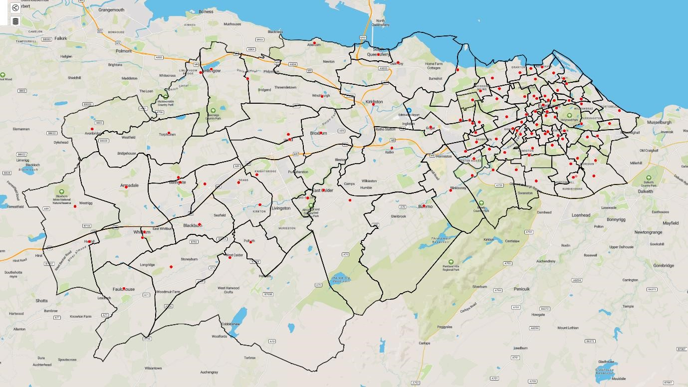

Edinburgh West Lothian Parishes and NHS Districts

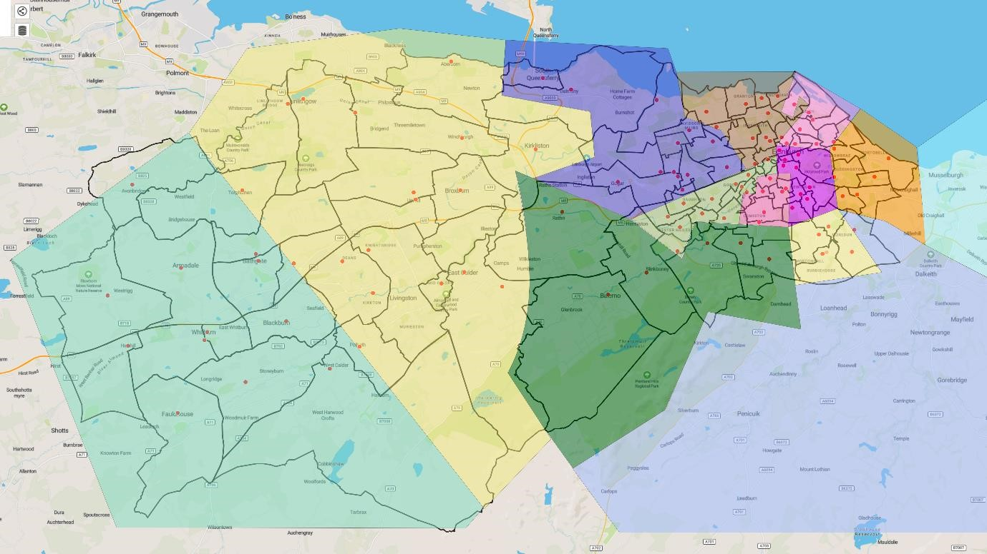

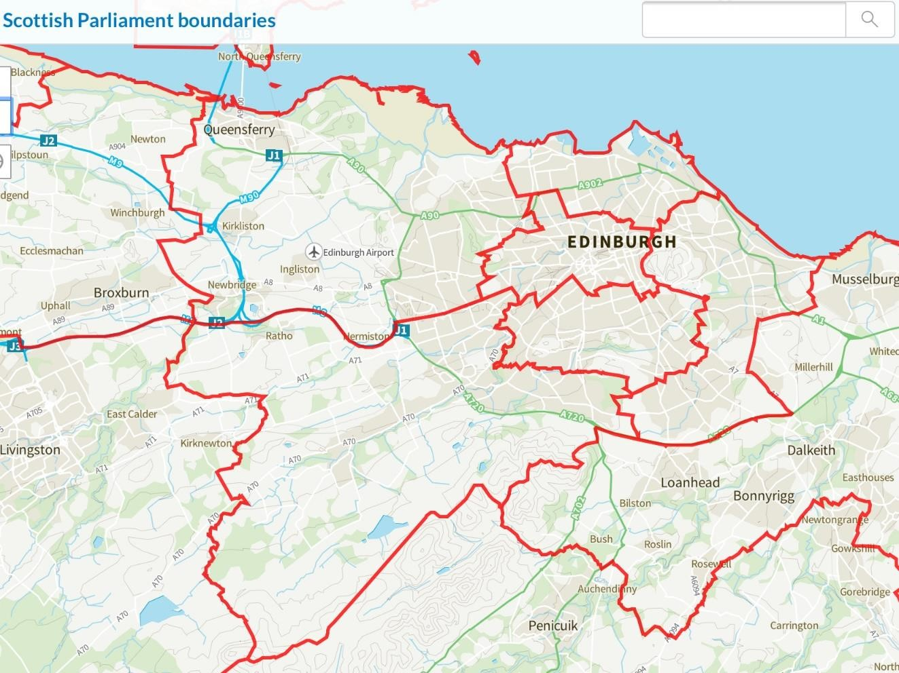

Council Ward Boundaries
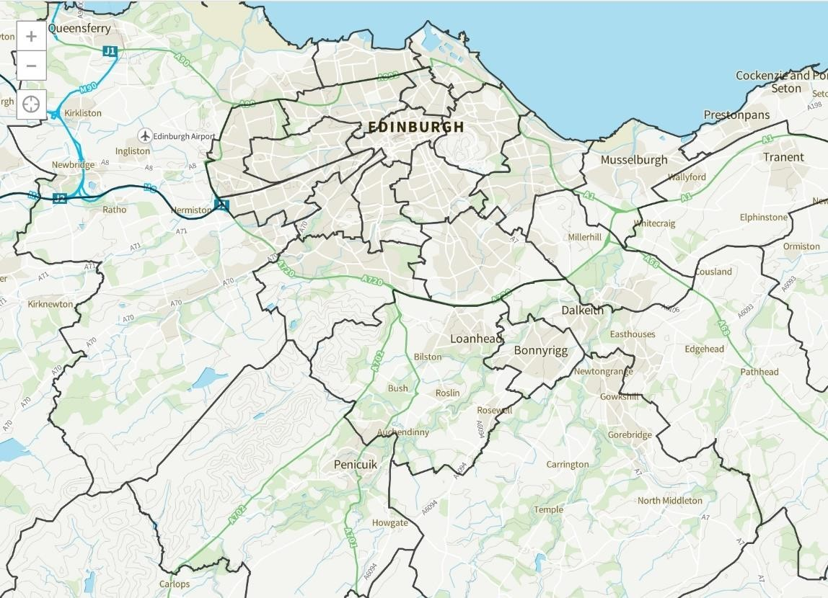
APPENDIX 6 – MISSION DISTRICT STATISTICS
